CURRICULUM OVERVIEW YEAR 4
 | Autumn 1 |  | Autumn 2 |  | Spring 1
ENGLISH BOOK | The Day the Crayons Quit |  | Leon and the Place Between |  | The Iron Man
Maths | Place Value  Addition & Subtractions |  | Length & Perimeter  Multiplication & Division |  | Multiplication & Division  Area / Fractions
SCIENCE | Animals Including Humans |  |  |  | Electricity
HISTORY | The Romans |  | Anglo Saxons
GEOGRAPHY |  |  |  |  | Recycling
DESIGN & TECHNOLOGY |  |  | Food |  | Electrical System
ART & DESIGN | Roman Pottery
COMPUTING | Fake or Real? |  | Hour of Code |  | Dinosaurs
RELIGIOUS EDUCATION | Buddhism |  | Angels & Shepherds |  | The Bible
MUSIC | Keyboards / Mamma Mia |  | Keyboards/ Glockenspiel 2 |  | Keyboards / Stop
PHYSICAL EDUCATION | Gymnastics |  | Football |  | Swimming / Basketball
SPANISH
PSHE | Being me in my world |  | Celebrating Differences |  | Dreams & Goals
ENRICHMENT/VISITS | Zoo Lab
AUTHOR  David Walliams |  | ARTIST  Andy Warhol  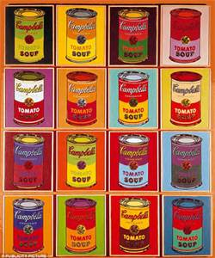 |  | COMPOSER  Freddie Mercury / Beethoven  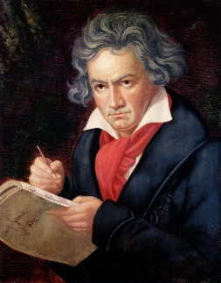

CURRICULUM OVERVIEW YEAR 4
 | Spring 2 |  | Summer 1 |  | Summer 2
ENGLISH BOOK | The Spiderwick Chronicles |  | Charlotte’s Web |  | Billionaire Boy
Maths | Fractions / Decimals |  | Decimals  Money / Time |  | Statistics/ Position & Direction  Properties of Shape
SCIENCE | Sound |  | Living things & their habitats |  | Solids, Liquids & Gases
HISTORY |  |  | The Vikings
GEOGRAPHY | The Mediterranean |  |  |  | Investigating the local area
DESIGN & TECHNOLOGY |  |  | Mechanical Structures
ART & DESIGN | European Art |  |  |  | Liverpool skyline
COMPUTING | My Online Life |  | Wizard School |  | Minecraft Challenges
RELIGIOUS EDUCATION | Easter |  | Special Places |  | Journeys
MUSIC | Keyboards / Lean on me |  | Keyboards / Blackbird |  | Keyboards / Reflect, Rewind, Replay
PHYSICAL EDUCATION | Hockey |  | Athletics |  | Cricket
SPANISH | European Countries |  | Animals |  | Classroom Equipment
PSHE | Healthy Me |  | Relationships |  | Changing Me
ENRICHMENT/VISITS |  |  | Jorvik Centre
AUTHOR  David Walliams |  | ARTIST  Andy Warhol |  | COMPOSER  Freddie Mercury / Beethoven  