CURRICULUM OVERVIEW YEAR 3
 | Autumn 1 |  | Autumn 2 |  | Spring 1
ENGLISH BOOK | The Great Kopak Tree  Shape poems |  | Stone Age Boy / Ug |  | Gorilla
Maths | Place Value  Addition & Subtraction |  | Multiplication & Division |  | Multiplication & Division  Money
SCIENCE | Health & Movement |  | Rocks & Soils |  | Forces & Magnets
HISTORY |  |  | The Stone Age
GEOGRAPHY | Rainforest |  |  |  | Deserts
DESIGN & TECHNOLOGY |  |  |  |  | Textiles
ART & DESIGN | Sketching |  | Sculpture
COMPUTING | Rainforests |  | My Online Life |  | Online Detectives
RELIGIOUS EDUCATION | Rules & Responsibility |  | Care & Concern |  | Sikhism
MUSIC | Recorders / Let your spirit fly |  | Recorders / Glockenspiel 1 |  | Recorders / Three little birds
PHYSICAL EDUCATION | Gymnastics |  | Tag Rugby |  | Netball
SPANISH
PSHE | Being me in my World |  | Celebrating Differences |  | Dreams & Goals
ENRICHMENT/VISITS
AUTHOR  Dick King Smith  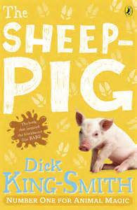 |  | ARTIST  Charles Rennie Mackintosh  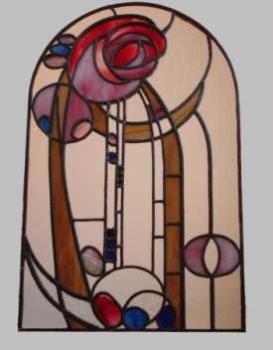 |  | COMPOSER  Adele / Motzart  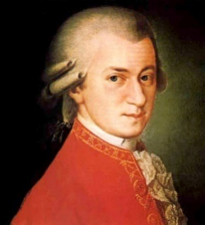

CURRICULUM OVERVIEW YEAR 3
 | Spring 2 |  | Summer 1 |  | Summer 2
ENGLISH BOOK | Egyptian Cinderella  Who killed Tutankhamun? |  | Ottoline & the Yellow Cat |  | Where would you like to live?
Maths | Length & Perimeter  Fractions |  | Fractions  Time |  | Properties of Shape  Mass & Capacity
SCIENCE | Light |  | Plants
HISTORY | The Egyptians |  |  |  | Railways
GEOGRAPHY |  |  | The United Kingdom
DESIGN & TECHNOLOGY |  |  | Structures |  | Food
ART & DESIGN | Hieroglyphics /Papyrus making
COMPUTING | Dancing Robots |  | Keyboard Adventures |  | T-Shirt Designer
RELIGIOUS EDUCATION | Easter |  | Special People |  | Special People
MUSIC | Recorders / The Dragon Song |  | Recorders / Bringing us together |  | Recorders / Reflect, Rewind, Replay
PHYSICAL EDUCATION | Swimming / Dance |  | Athletics |  | Tennis
SPANISH
PSHE | Healthy Me |  | Relationships |  | Changing Me
ENRICHMENT/VISITS | Museum visit
AUTHOR  Dick King Smith |  | ARTIST  Charles Rennie Mackintosh |  | COMPOSER  Adele / Motzart  