CURRICULUM OVERVIEW YEAR 1
 | Autumn 1 |  | Autumn 2 |  | Spring 1
ENGLISH BOOK | The Jolly Postman / The Emperors Egg |  | Why do elephants have big ears? / Fantastic Poems |  | Orion & the dark / 10 things to help my world
Maths | Place Value (10) / addition & subtract |  | Addition & subtraction (10)  Shape / Place Value (20) |  | Addition & Subtraction (20)
SCIENCE | My body |  | Identifying animals |  | Everyday materials
HISTORY |  |  | Toys – past & present |  | What makes a good explorer?
GEOGRAPHY | Where I live
DESIGN & TECHNOLOGY |  |  | Moving pictures
ART & DESIGN | Self portraits |  |  |  | Paper Art
COMPUTING | What is a computer? |  | Modern tales |  | Drawing maths
RELIGIOUS EDUCATION | Harvest of hands |  | Christmas |  | New beginnings
MUSIC | Hey you |  | Rhythm in the way we walk |  | In the Groove
PHYSICAL EDUCATION | Gymnastics |  | Team games |  | Dance
PSHE | Being me in my world |  | Celebrating differences |  | Dreams & Goals
ENRICHMENT/VISITS |  |  | Pantomime
AUTH0R  Oliver Jeffers  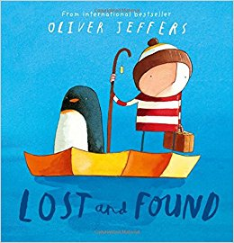 |  | ARTIST  Mondrian  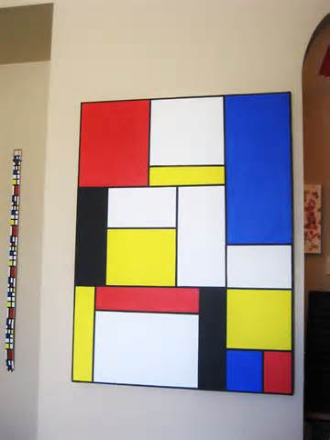 |  | COMPOSER  Vivaldi & Abba  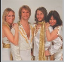  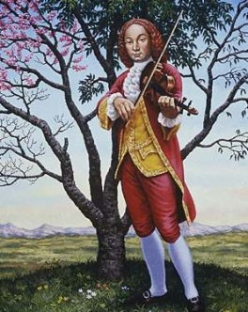

CURRICULUM OVERVIEW YEAR 1
 | Spring 2 |  | Summer 1 |  | Summer 2
ENGLISH BOOK | Top Jobs / Big, Bad, Owl |  | The Storm Whale  Out and about |  | Beegu
Maths | Measurement |  | Multiplication & Division  Fractions |  | Geometry / Place Value  Money / Time
SCIENCE |  |  | Seasonal Change |  | Plants
HISTORY |  |  | The Beatles
GEOGRAPHY | On the farm |  |  |  | Seaside – UK & tropical
DESIGN & TECHNOLOGY |  |  | Eat more fruit & veg
ART & DESIGN | Structures |  |  |  | Andy Goldsworthy
COMPUTING | Mini beasts |  | My online life |  | Animate with shapes
RELIGIOUS EDUCATION | Easter |  | Our wonderful world |  | Our wonderful world
MUSIC | Round and Round |  | Your imagination |  | Reflect, Rewind, Replay
PHYSICAL EDUCATION | Travelling with equipment |  | Athletics |  | Catching & throwing games
PSHE | Healthy Me |  | Relationships |  | Changing Me
ENRICHMENT/VISITS | Farm visit |  |  |  | Seaside
AUTH0R  Oliver Jeffers |  | ARTIST  Mondrian |  | COMPOSER  Vivaldi & Abba

