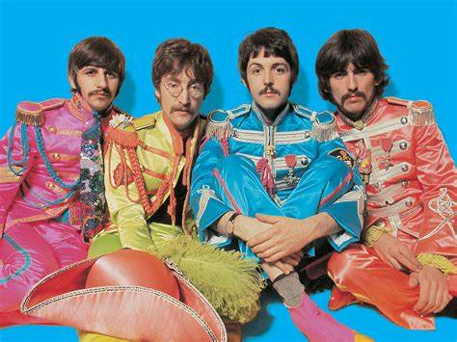

**Year 1 – Summer 1 2021  
Topic – The Beatles**

**Maths**

Multiplication & Division

Fractions

Geometry

**English  
Fiction – The Storm Whale**  
The children will explore themes and issues in this story and develop ideas through discussion, drama, storytelling and artwork,

**Poetry – Out and About: A First Book of Poems.**

The children will compare and contrast different poems by exploring structure, language and meaning and then construct their own poems in groups and independently.

**Computing – My Online Life**

The children will be thinking about their online presence and different ways in which they can represent themselves online.

**Music**

Your Imagination

**History – The Beatles**

The children will be looking at changes within living memory and changes in national life with particular focus on Beatlemania and teenagers.

**PE**Athletics

**RE – Our Wonderful World**

We will be learning about how different religions view the creation story and asking ourselves ‘What makes the World Special?’

**Science – Plants**

Within our science topic of plants children will be learning how to identify ad name a variety of wild and garden plants.

They will also be growing some plants of their own throughout this term!

**Design Technology – Eat More Fruit and Vegetables!**  
Children will find out one another’s favourite fruits and vegetables and look at healthy recipes that include them!

**PE**

Children will have weekly PE lessons with UK Sports.

Children will also have a 2 week block of swimming lessons – 16th to 26th January.