LO: To review our understanding of light and shadow and to explore how light travels
Copy the paragraph below in your textbooks.
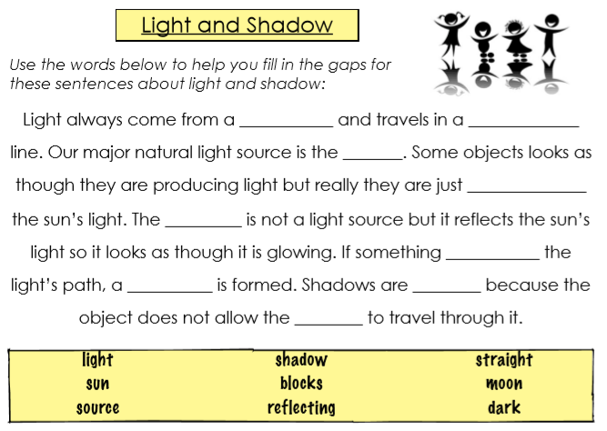

Use a torch or mobile phone and place it in front of an object as shown below. Draw a picture of the shadow and post it on Seesaw. What happens when you move the light source closer to/further away from the object?
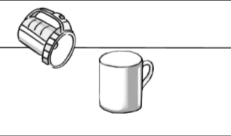

- Name 3 natural light sources:
- Name 2 artificial light sources:
- Use a dictionary to write a definition of these words: ➡ Transparent➡ Translucent➡ Opaque

