CURRICULUM OVERVIEW YEAR 5
 | Autumn 1 |  | Autumn 2 |  | Spring 1
ENGLISH BOOK | The Journey |  | Oranges in no-mans land |  | Odysseus
Maths | Place Value  Addition & Subtraction |  | Statistics / Perimeter & Area  Multiplication & Division |  | Multiplication & Division  Fractions
SCIENCE |  |  | Forces in action |  | Materials
HISTORY | Shang Dynasty |  |  |  | Ancient Greeks
GEOGRAPHY |  |  | Extreme Earth
DESIGN & TECHNOLOGY |  |  | Structure - Raft making |  | Bread
ART & DESIGN | Landscapes
COMPUTING | My Online Life |  | You Tuber |  | Girls v Boys Steam Challenges
RELIGIOUS EDUCATION | Precious |  | Christmas in Art |  | Christianity
MUSIC | Livin’ on a Prayer |  | Classroom Jazz 1 |  | Make you feel my love
PHYSICAL EDUCATION | Gymnastics |  | Tag Rugby |  | Swimming / Netball
SPANISH
PSHE | Being me |  | Celebrating differences |  | Dreams & goals
ENRICHMENT/VISITS | Harvest festival
AUTHOR  Frank Cottrell Boyce  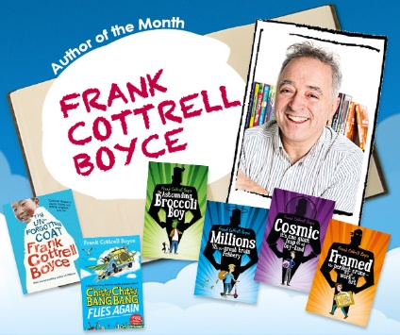 |  | ARTIST  Salvador Dali  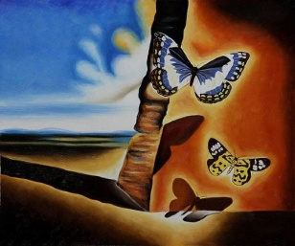 |  | COMPOSERS  Andrew Lloyd Webber / Holst  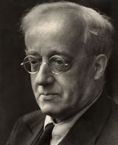

CURRICULUM OVERVIEW YEAR 5
 | Spring 2 |  | Summer 1 |  | Summer 2
ENGLISH BOOK | Varmints/ Animals on the move |  | Cosmic / Cosmic Disco |  | Running on Empty /  Tom’s Midnight Garden
Maths | Fractions  Decimals & Percentages |  | Decimals / Shape  Position & Direction |  | Converting Units  Volume
SCIENCE | Life Cycles – Living things |  | Earth & Space |  | Changes & Reproduction
HISTORY |  |  | The British Empire
GEOGRAPHY | Marvellous Maps |  |  |  | United States of America
DESIGN & TECHNOLOGY | Electrical Systems
ART & DESIGN |  |  | Painting Planets |  | Textiles - Tapestry
COMPUTING | Video Games Music Composer |  | Making AR Games |  | News reporter and Podcast
RELIGIOUS EDUCATION | The Natural World |  | Islam |  | Cathedrals
MUSIC | Fresh Prince of Belair |  | Dancing in the street |  | Reflect, Rewind, Replay
PHYSICAL EDUCATION | Dance |  | Athletics |  | Tennis
SPANISH
PSHE | Relationships |  | Healthy me |  | Changing me
ENRICHMENT/VISITS |  |  | Visit to Spaceport
AUTHOR  Frank Cottrell Boyce  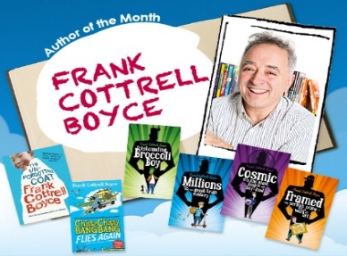 |  | ARTIST  Salvador Dali |  | COMPOSER  Andrew Lloyd Webber / Holst

