Autumn 1
Year 2
Class artist: Paul Klee
Class authors: Julia Donaldson
Class Composer: Ravel & Bob Marley
Literacy:
Wordsmith
Fiction: 2:1 What would you do? (books Silly Billy & Operation Night Monster)
Power of Reading book ‘Pattan’s Pumpkin’

Punctuation & Grammar
Spelling
Guided Reading 

Numeracy
- Number & Place Value
- Number addition & subtraction
- Times tables 2 5 10
- Mastery
- Problems solving & reasoning.
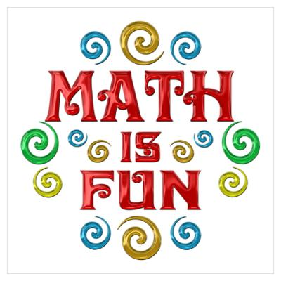
Computing: ‘my Online Life’
- Understand that I cannot trust everyone online
- Use online services to communicate safely.
- Understand that once something is posted online you loose control of it.
- Give examples of online bullying.

RE : Importance of light in religious festivals.
- Hinduism
- Divali
- Festivals of Light
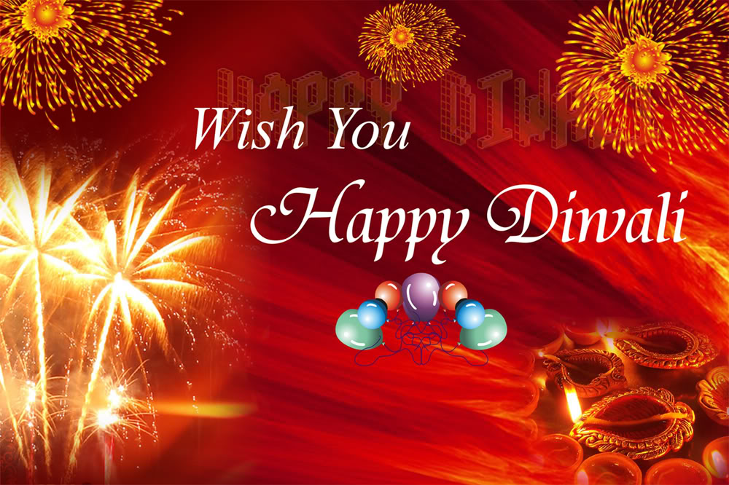

8523

History: Local History
- Where I live. Kirkby /Knowsley
- Local area in the past
- Walkabout to visit local historical landmarks
- History of Lord Derby & estate
- Knowsley Hall
- Selling and development of lands after war
- Kirkby then and now

wali

Science: Investigating everyday materials :
- To be able to identify a range of materials and sort them according to a variety of criteria.
- To be able to identify natural an man-made materials.
- To identify that some materials can change shape by squashing, bending, stretching and twisting, and others can’t.
- To identify the suitability of metal and plastic for a variety of purposes.
- To identify different products that can be made from wood and their features and purposes.
- To identify different materials that are used for the same product.
- To identify material inventions and discoveries.

Art: investigating Materials
- Describing materials
- Joining materials
- Fabric fun
- Paper weaving
- Weaving

PSHE:
Rules
Being me in my World

PE: Gymnastics
- Balance
- Form
- Sequencing
- Warm up/down
- Healthy exercise & benefits
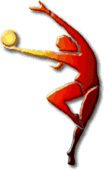

‘Charanga’ Music scheme
‘Hands, Feet, Heart.’ By J. Mangona- a song that celebrates South African music
.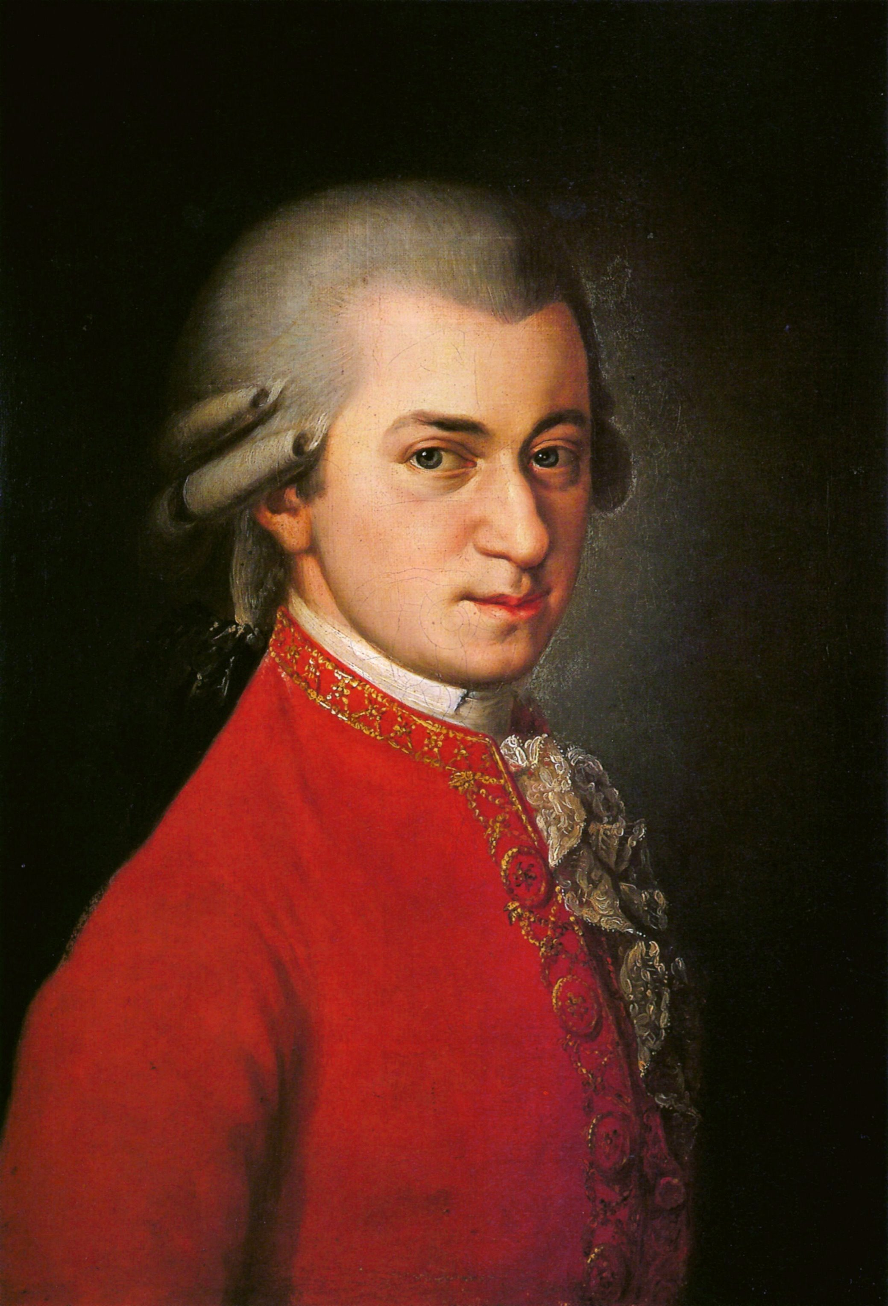 Mozart

