English

Reading

* The Day the Crayons Quit
* Leon and the Place Between

Writing

* Recount – diary
* Newspaper
* Advert
* Instructions
* Poetry
* Letters
* Story
* Written predictions
* Performance Reading
* Creating characters and events
* Persuasive poster
* Writing in role
* Story maps

RE – Buddhism

The Buddha’s early life.

Enlightenment.

Teachings of the Buddha.

Maths

Place Value

Addition & Subtraction

Multiplication & Division

Measurement

P.S.H.E

Jigsaw Unit 1 – being me in My World

Music

Keyboards with Mr Oats

Singing Mrs Hughes

PE

– Mr Carson (Tuesdays)

Computing

Fake or Real?

What is fake news?

Science – **Where does all that food go?**

The Digestive System in humans and animals

Teeth in humans and animals

Art & Design

Work linked to class artist – Andy Warhol

Work linked to Romans topic - **POTTERY**

Taught Fridays by Mr Carson

Modern Foreign Languages

Spanish

Taught by Spanish Specialist

The Romans

Y4 Autumn 1 2020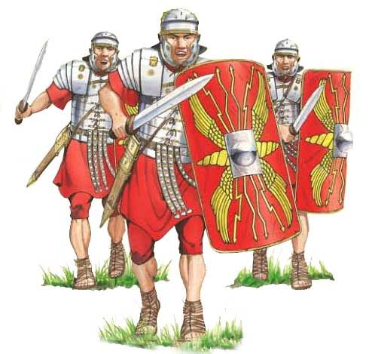



Topic- History – The Romans

Our Enquiry question will be:

***How did the arrival of the Romans change Britain*?**

We will be finding out Why Emperor Claudius invaded Britain and how the Romans almost lost control of Britain.