CURRICULUM OVERVIEW YEAR 6
 | Spring 2 |  | Summer 1 |  | Summer 2
ENGLISH BOOK | Shackleton’s Journey |  | What blood is for |  | Salamander Dream
Maths | Measuring / Ratio |  | Properties of Shape / Statistics |  | Investigations
SCIENCE | Living things - classification |  | Healthy Body - heart
HISTORY |  |  | Our city - Liverpool
GEOGRAPHY | Antarctica |  | Our city - Liverpool
DESIGN & TECHNOLOGY | Designing Sledges - timber
ART & DESIGN |  |  | Van Gogh |  | Digital art
COMPUTING | Crossy Roads |  | Maths Solve IT Club |  | Quiz-Show Host
RELIGIOUS EDUCATION | Easter |  |  |  | Judaism
MUSIC | Rhythm & Pulse |  | Musical Processes |  | Performing Together
PHYSICAL EDUCATION | Hockey |  | Athletics |  | Cricket
SPANISH | Homes/Families |  | Our body |  | Weather / months / Seasons
PSHE | Relationships |  | Healthy me |  | Changing me
ENRICHMENT/VISITS | Residential to Kingswood |  |  |  | Liverpool visit
AUTHOR  Michael Morpurgo  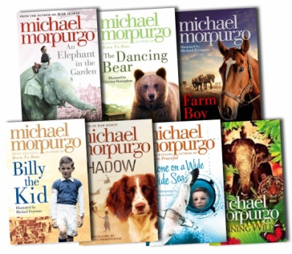 |  | ARTIST  Vincent van Gogh  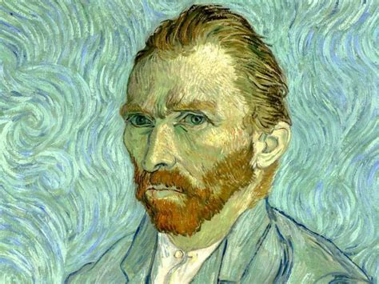 |  | COMPOSERS  John Lennon / Tchaikovsky  