CURRICULUM OVERVIEW YEAR 6
 | Autumn 1 |  | Autumn 2 |  | Spring 1
ENGLISH BOOK | Friend or Foe |  | Journey to the River Sea |  | Kensuke’s Kingdom
Maths | Place Value/4 operations |  | Fractions / Geometry |  | Decimals/Percentages/Algebra
SCIENCE | Evolution & Inheritance |  | Changing Circuits |  | Light – how we see things
HISTORY | Britain at War |  |  |  | The Aztecs
GEOGRAPHY |  |  | South America
DESIGN & TECHNOLOGY | Design a bag - textiles
ART & DESIGN |  |  | Painting – Landscapes |  | Pastels / Collage - Aztec Art
COMPUTING | My Online Life |  | Online Safety Dilemmas |  | VR Worlds
RELIGIOUS EDUCATION | Christian faith in action |  | Promises & Magi |  | Choices
MUSIC | Exploring rounds |  | Sound sources |  | Lyrics & Melody
PHYSICAL EDUCATION | Swimming / Gymnastics |  | Football |  | Basketball
SPANISH | Greetings/numbers/colours |  | Classroom vocab / Christmas |  | Animals
PSHE | Being me |  | Celebrating differences |  | Dreams & Goals
ENRICHMENT/VISITS | Eden Camp |  |  |  | Cadbury World
AUTHOR  Michael Morpurgo  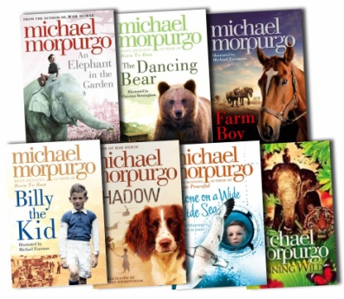 |  | ARTIST  Vincent van Gogh  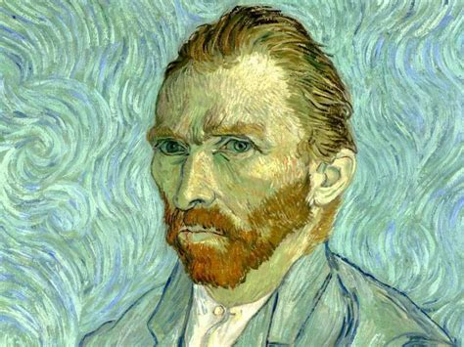 |  | COMPOSERS  John Lennon / Tchaikovsky  