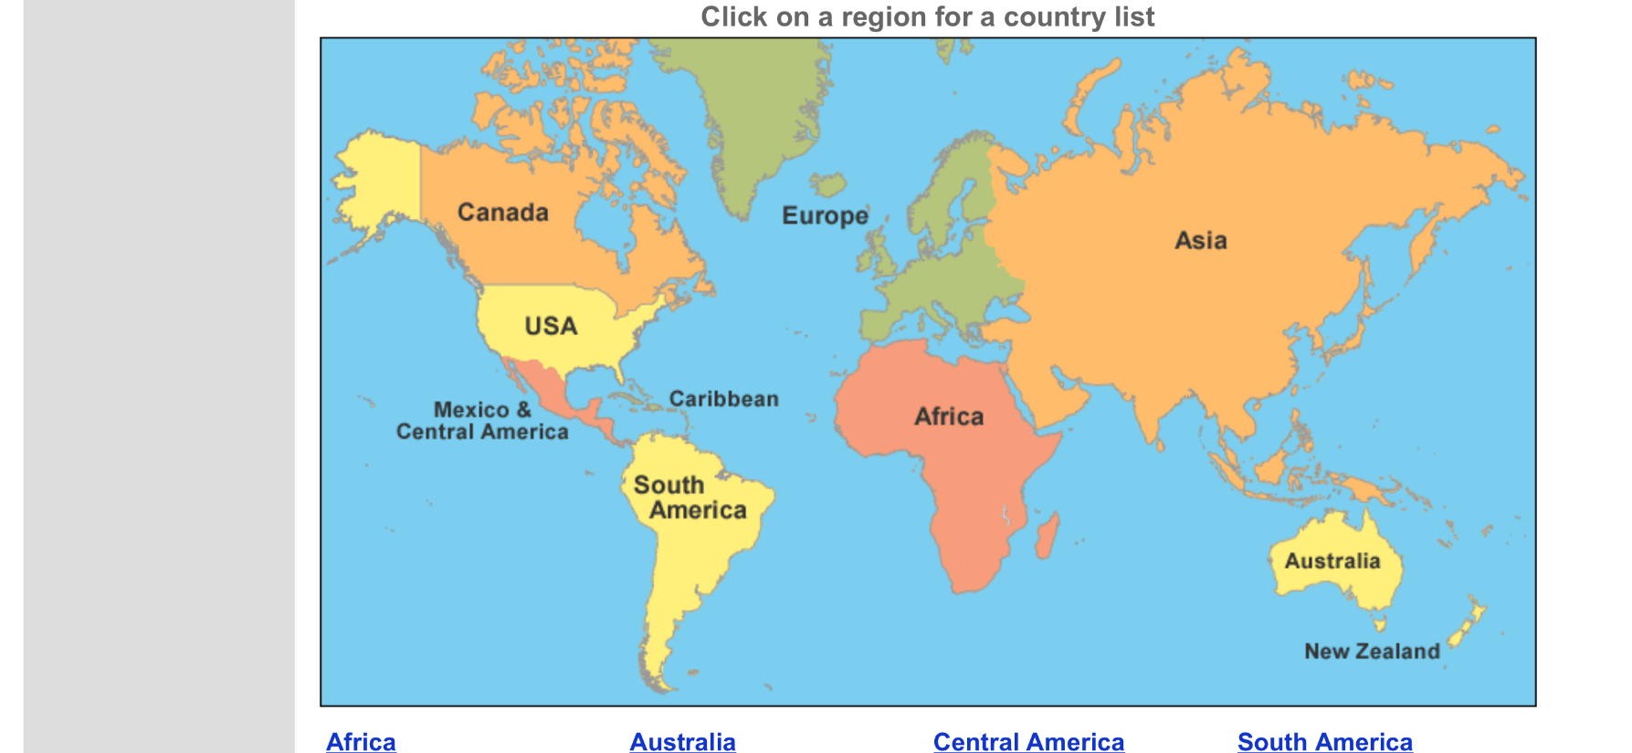
Summer 2 2019
Countries of the World
Hvvvvyyyytyr6er

Maths
Measure
Properties of 2D and 3D shape
Problem Solving
Consolidation

English
Spelling, punctuation and Grammar-
Where would you like to Live? Exploring non-fiction texts about countries around the work.
Culture Story-The Plastic Bag
-The Plastic Bag
Sto

Science
How plants grow?
Identify and describe the functions of the roots and of flowering plants.
Seed dispersal.
Seed structure

Computing
Big Robots
Reinforce children’s understanding of directional language and programming.
Explain the importance and meaning of algorithms.
Music
Recorders

Learning notes B,A,G
Geography
Countries of the world.
Identify continents in the world.
Locate countries on a world a world map.
Locate major capital cities.
Similarities/differences

RE
Special Place
Discuss special places
Why are places special?
Inside a church
Mosque
Synagogue

MFL
Months of the year
Days of the week
Birthdays
Playing games
Celebrations
DT
Food
Sandwiches from around the world!
Plan, make and evaluate a healthy sandwich from around the world.
PE
Striking and fielding

