Information books and stories about plants eg ‘Jack and the Beanstalk’, ‘The Enormous Watermelon’.

Paper, card, range of writing equipment.

Play food items to count and weigh.

Masks/props to re-enact stories eg ‘Handa’s Surprise’.

Large and small construction materials – Mobilo, Duplo, Lego, Sticklebrix, wooden blocks, crates, fabrics.

Cardboard, paper, plastic for model making.

Online information about healthy eating.

**Resource implications**

 Jolly Phonics CD and letter sound cards, word cards using sounds taught. Non-fiction books and stories about bears./toys.

Whiteboards/markers, paints, pencils/pens, paper/card, envelopes, colouring sheets.

Magnetic numbers, counters and worksheets.

3D shapes, weighing scales, tape measures

Stories/information books/online information about plants grown for food.

Musical instruments and range of materials

**Focused Activities**

Continue Oxford Reading Tree books and Jolly Phonics – linking letters to sounds, using songs and actions to support learning. Shows interest in a range of story and information books related to topic.

Writes sentences which can be read by themselves/others.

Forms letters correctly. Shows control and co-ordination in large and small movements.

Counts objects to 20 and matches to number. Can add and subtract.

Understanding of 3D shapes. Awareness of weight/distance.

Shows interest in different occupations – farmer. Develops understanding of similarities and differences between plants and animals found in different world environments.

Explores different materials, colours and textures, Experiments with singing and making music.

**Areas of learning**

Reading

Writing

Physical Development

Numbers

Shape, Space and Measures

Understanding The World

Expressive Arts and Design

Stories and information books related to Healthy Eating topic. Free book choices and Oxford Reading Tree books to share with parents/carers at home. IPads for information.

Writing for a purpose eg writing about favourite foods, making lists of fruit and vegetables.

Counting objects to 20. Counts money to pay for food. Gives change.

Props in dentist’s surgery indoors, including dentist’s chair, toothbrushes, toothpaste, telephone, writing materials.

Construction materials for indoor and outdoor model making.

Junk materials for making models/painting pictures.

IPads and interactive whiteboard for information.

**Areas of indoor / outdoor provision**

Reading areas in and outdoors

Writing areas in and outdoors

Maths in and outdoors

Role play

Construction in and outdoors/Small world

Creative - art and workshop

Technology

**Expressive Arts and Design**

**Exploring using media and materials:** Explores a variety of materials and experiments with colour and textures. Sings songs, makes music and dances.

**Being imaginative:**

Represents their own thoughts, ideas and feelings through art, music, dance, role play and stories.

**Physical Development**

**Moving and handling:** Shows good control and co-ordination. Handles tools and equipment effectively. Forms letters correctly.

**Health and self-care:** Knows ways to stay healthy eg eats a healthy diet including fruit and vegetables. Knows how to stay safe, showing awareness of dangers.

**Understanding The World**

**People and communities:** Knows about similarities and differences between different communities eg world foods.

**The world:** Knows about similarities and differences between places and living things eg that different plants and animals are found in different countries.

**Technology:** Recognises that a range of technology is used in homes and schools, eg laptop, camera, iPad, DVD, mobile phone.

**Summer 1 2019**

**Reception**

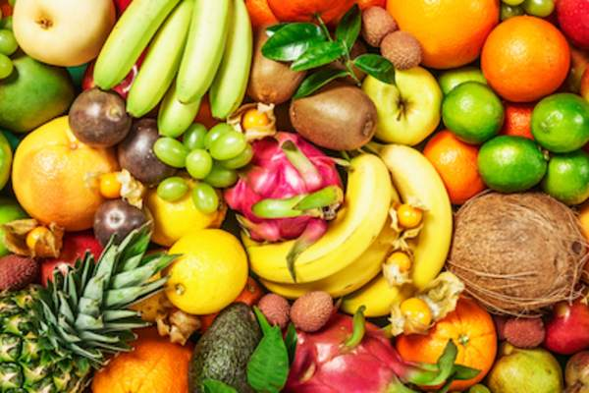

**Plants and healthy eating**

**Mathematics**

**Numbers:** Counts reliably with numbers to 20 and puts them in order. Can say the number that is 1 less or 1 more than a given number. Adds and subtracts two single-digit numbers.

**Shape, Space and Measures:** Uses names for **3D shapes** eg cube, cone, pyramid, sphere and mathematical language (faces, curved, flat). Recognises, creates and describes patterns eg uses counters to create a pattern blue, orange, blue, orange. Uses everyday language to talk about weight and distance.

**Communication and Language/**

**Reading and writing**

**Listening and attention:** Listens to stories, responds with relevant comments/questions.

**Understanding:** Answers ‘how’ and ‘why’ questions about stories/own experiences.

**Speaking**: Uses past, present and future tenses correctly when talking about events that have happened/are about to happen.

**Reading:** Enjoys an increasing range of books. Reads words and simple sentences, Understands what they have read.

**Writing:** Uses phonic knowledge. Writes simple sentences which can be read by themselves and others.

**Managing Feelings and Behaviour:**

Works as part of the class, understanding and following school rules.

**Making Relationships:**

Shows sensitivity towards others’ needs and feelings. Forms positive relationships.

**Areas of learning – Health & Self-Care, People & Communities, Reading, Writing, Maths**

***Power of Reading* book choices for this half term: ‘Handa’s Surprise’ by Eileen Browne and ‘Anna Hibiscus’ Song’ by Atinuke and Lauren Tobia.**

**Self-Confidence & Self-Awareness:**

Confident to try new activities and speak in a familiar group. Will talk about own ideas.