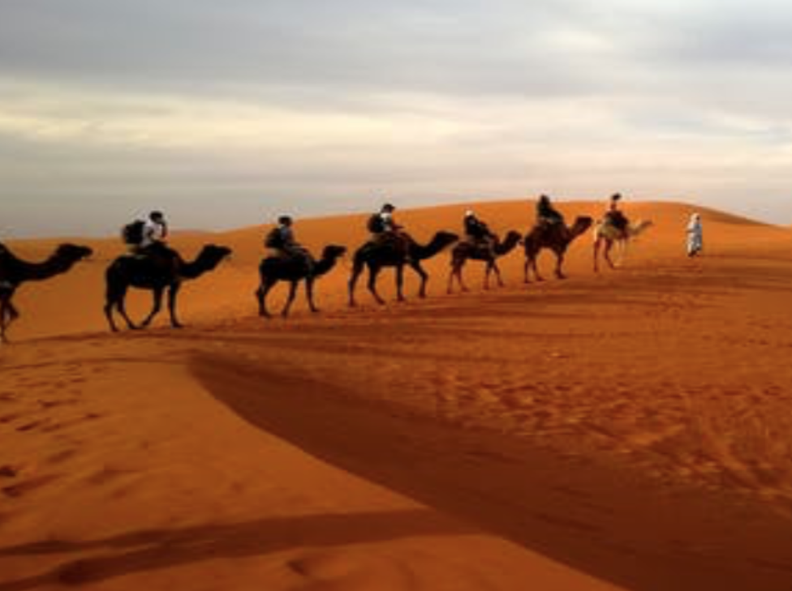 THE WILD WEST 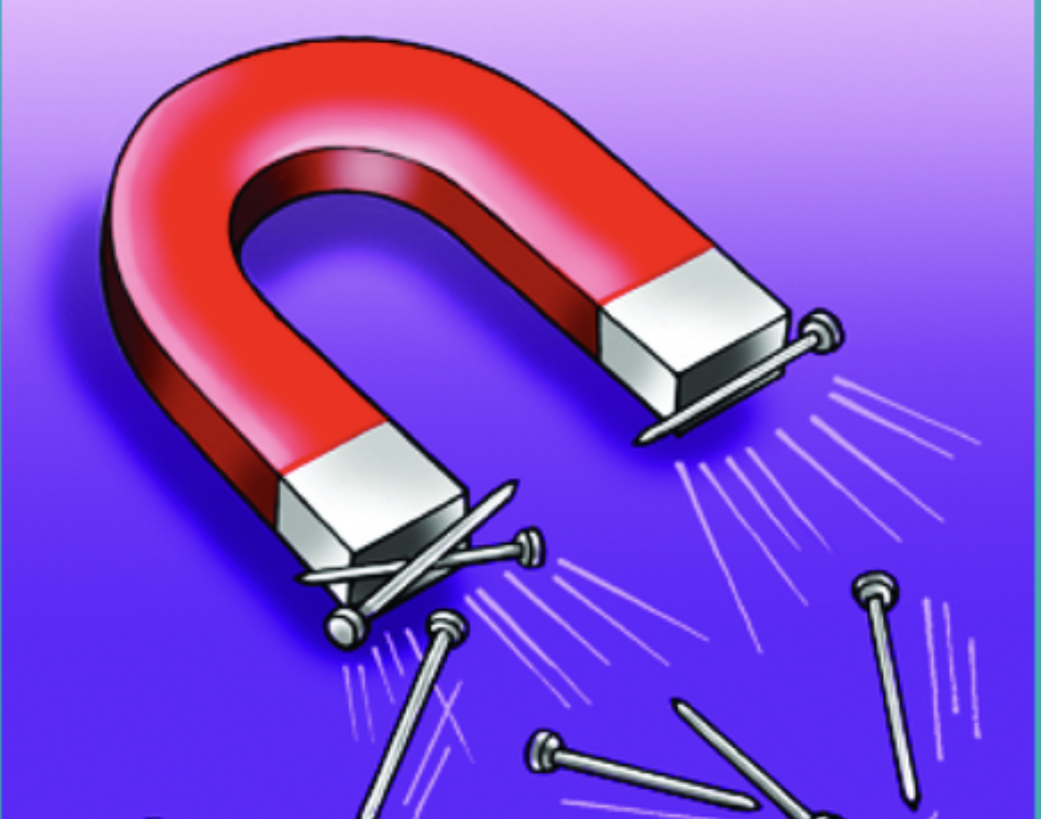
Spring 2 2019
In the Desert

English
Spelling, punctuation and Grammar
Guilder Reading
Poetry-playing with words
Non Fiction- Where would you like to live?
Maths
Times Tables
Statistics
Measures- Length
Weight
Perimeter
Fractions

Science
Forces and Magnets 2
Scientific enquiry
Make predictions
Test hypothesis
Make conclusions

Computing
We love Games
Create an algorithm. Test it,’ improve it. Use ‘Hopscotch app
Link to ‘A day in the desert.’

RE
Easter
Easter Story
How we Celebrate Easter
Easter Traditions.

Geography
Deserts
Locate deserts across the world.
Research climates.
Extended writing-Lost in the desert.
Music
Recorders

Learning notes B,A,G

Art
Portraying Relationships.
Study various paintings and images of different relationships, sketch own images.
PE
Swimming

MFL
Simple conversation
Where I live
Colours
Animal-Desert
Counting to 20

