Literacy
Non-fiction – What ‘s the most Unusual place to live in the World?
Florence Nightingale
Poetry- A Closer Look

SAT’s reading & writing
Spellings
Guided reading

Spring 2 Year 2

Class artist: Paul Klee
Class authors: Julia Donaldson & Jez Alborough
Class Composer: Bob Marley

Numeracy

- Multiplication & division
- Statistics
- Fractions
- Properties of shape.
SAT’s arithmetic and numeracy skills

RE : Easter Alive
- How do we celebrate special occasions?
- The Last Supper
- Good Friday
- Easter Sunday
- Signs and Symbols

PE: Games
- Throwing and catching
- Using a target
- With a partner
- Striking a ball
- Make up games

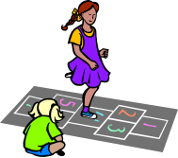

History: Florence Nightingale
- Early Life
- The Journey to Scutari
- Making Changes
- A Celebrity
- Similarities and Differences
- A Remarkable Life

- 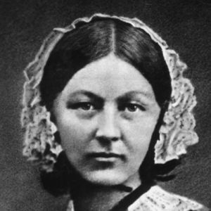

‘Charanga’ Music scheme

Computing CLC
‘You’ve got mail’
- Children gain an understanding of email.
- Children learn how to send emails.
- What can I share? Importance of keeping personal information private.
- Set up and use Edmodo
- ‘let’s get posting’ children will learn how to add a profile picture/ participate in a class poll.
class ipads
computer suite

DT Vehicles
- Vehicle Features
- Wheels, Axles and Chassis
- Bodywork
- Designing Vehicles
- Making Vehicles
- Evaluation


P.S.H.E
Dreams and goals
JIG-SAW
‘Charanga’ Music scheme

Science: Growth & Survival
- Offspring
- Reproduction
- Growing Up
- Survival Needs
- Environments
- Healthy Eating
- Exercise


Art: Colour creation
- Favourite colours
- Primary colours
- Mixing colours
- Light & dark
- Kandinsky Circles

Science: growing Plants
- Seeds
- Bulbs
- How are seeds dispersed?
- Investigating germination conditions
- Investigating germination conditions


