**Resource implications**

 Jolly Phonics CD and letter sound cards, word cards using sounds taught. Non-fiction books and stories about bears./toys.

Whiteboards/markers, paints, pencils/pens, paper/card, envelopes, colouring sheets.

Magnetic numbers, counters and worksheets.

2D and 3D shapes, clocks, money.

Stories/information books/online information about bears/toys.

Range of musical instruments, Songs related to bears eg ‘Teddy Bears’ Picnic’.

**Focused Activities**

Continue Oxford Reading Tree books and Jolly Phonics – linking letters to sounds, using songs and actions to support learning. Shows interest in a range of story and information books.

Writes words and simple sentences in meaningful contexts.

Uses a pencil to form recognisable letters, mostly correctly formed.

Counts objects beyond 10 and matches to number. Forms numbers correctly. Can add and subtract.

Understanding of 2D/3D shapes. Awareness of time/money.

Shows interest in different occupations – shopkeeper. Develops understanding of similarities and differences between toy/real animals and environments wild animals live in.

Explores sounds made by musical instruments. Mixes colours to see what happens.

**Areas of learning**

Reading

Writing

Physical Development

Numbers

Shape, Space and Measures

Understanding The World

Expressive Arts and Design

Information books and stories about bears eg ‘We’re Going on a Bear Hunt’, ‘This is the Bear’ and ‘Old Bear’.

Paper, card, range of writing equipment.

Bear themed counters. Adding/subtracting worksheets. Money worksheets.

Re-enacting own experiences of visiting toy shops/buying toys.

Large and small construction materials – Mobilo, Duplo, Lego, Sticklebrix, wooden blocks, crates, fabrics.

Cardboard, paper, plastic for model making.

Online information about bears/toys.

Stories and information books related to Bears topic. Free book choices and Oxford Reading Tree books to share with parents/carers at home. IPads for information.

Writing for a purpose eg writing receipts for the toy shop, making price lists of toys.

Counting toys in the toy shop, counting money.

Props in role play area indoors, including shopkeeper’s apron, teddy bears and other toys, till and money. Outdoors – teddy bears picnic area.

Construction materials for indoor and outdoor model making – blocks and tyres for outdoors. Small world toy shop with figures.

Junk materials for making toys.

IPads and interactive whiteboard for information.

**Areas of indoor / outdoor provision**

Reading areas in and outdoors

Writing areas in and outdoors

Maths in and outdoors

Role play

Construction in and outdoors/Small world

Creative - art and workshop

Technology

**Expressive Arts and Design**

**Exploring using media and materials:** Explores the different sounds of instruments. Explores what happens when they mix colours.

**Being imaginative:**

Plays alongside others who are engaged in the same theme (eg in the toy shop). Introduces a storyline or narrative into their play.

**Physical Development**

**Moving and handling:** Uses anti-clockwise when writing, eg in letters a, c, d, e, g, o...

Retraces vertical lines eg in letters b, k, m, n, p….

**Health and self-care:** Shows some understanding that good practices with regard to exercise, eating, sleeping and hygiene can contribute to good health.

**Understanding The World**

**People and communities:** Talks about past and present events in family life, eg when taking home class bear.

**The world:** Knows about similarities and differences between objects and living things eg between toy bears and real bears. Develops understanding of environments.

**Technology:** Knows that information can be retrieved from computers and books, finds information about wild animals like bears.

**Spring 2 2019**

**Reception**

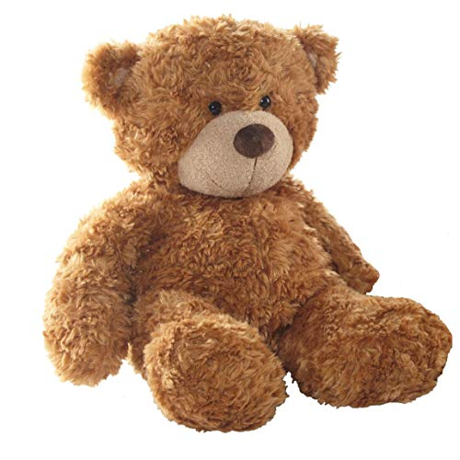

**Bears, bears, bears!**

**Mathematics**

**Numbers:** Uses the language involved in addition and subtraction. Can count objects beyond 10 (to at least 15). Can say the number that is 1 less or 1 more than a given number.

**Shape, Space and Measures:** Uses names for **2D shapes**, eg triangle, square, rectangle, pentagon and mathematical language to describe them (sides, corners).Uses names for **3D shapes** eg cube, cone, pyramid, sphere and mathematical language (faces, curved, flat).

Uses vocabulary related to time.

**Communication and Language/**

**Reading and writing**

**Listening and attention:** Maintains concentration and sits quietly during appropriate activity.

**Understanding:** Listens and responds to ideas expressed by others in discussions.

**Speaking**: Extends vocabulary, exploring the meaning and sounds of new words.

**Reading:** Reads words and simple sentences. Continues a rhyming string. Enjoys an increasing range of books.

**Writing:** Links sounds to letters, naming and sounding the letters of the alphabet. Attempts to write short sentences.

**Managing Feelings and Behaviour:**

Understands that actions affect others, eg comforts another child they have upset.

**Self-Confidence/Self-Awareness:**

Confident to talk to others about own needs, wants, interests and opinions.

**Areas of learning – Personal, Social, Emotional Development, Reading, Writing, Maths.**

***Power of Reading* book choices for this half term: ‘The Everywhere Bear’ by Julia Donaldson and ‘A Brave Bear’ by Sean Taylor.**

**Self-Confidence & Self-Awareness:**

Explains own knowledge and understands and asks appropriate questions of others.