Nursery Spring 2

Yucky Worms and Things That Grow in The Earth.

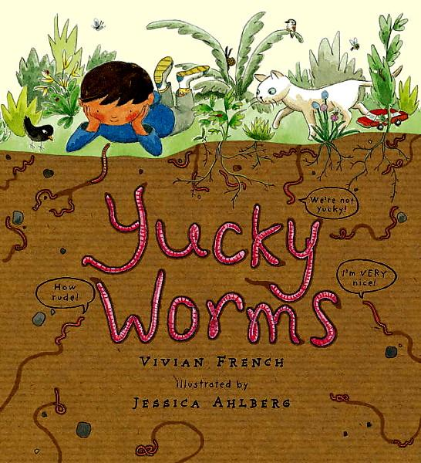

**Physical Development.**

This half term nursery will be continuing to focus on developing our physical skills in a range of ways. We will be using the climbing equipment outdoors to use alternate feet to climb, moving freely in a wide range of ways through games and activities, learning to balance on one foot and catch a large ball safely. We will also be encouraging the children to develop their independence as much as possible by encouraging them to dress independently.

**Communication and Language.**

Children will be encouraged to listen to others in one to one or small group situations and listen and respond to ideas expressed in conversations and discussion.

As we will be doing lots of investigating, enabling children to question why things happen and give explanations. As well as being able to follow clear instructions.

We will be beginning to retell a story in our own words or remember familiar phrases.

**Understanding the World.**

Nursery will be exploring all things natural and anything that grows or lives in the soil. we will be talking about some of the things we can observe such as plants, animals, natural found objects and mini beasts. As we explore we will be looking at growth over time and developing care and concern for living things.

We will also be looking at how information can be retrieved from computers.

**Expressive Art and Design.**

Nursery will be capturing experiences and responses in a range of media, such as music, dance and paint. We will be singing lots of new songs all about mini beasts and children will be encouraged to join in with songs and ring games, as well as imitating movements in response to music.

**Personal, Social and Emotional Development.**

Throughout this half term nursery will be encouraged to ask adults for help when needed and develop an awareness of our own feelings.

As the children continue to make friendships they will be encouraged to initiate play by offering clues to peers to join them.

Throughout activities, investigations and day to day play nursery will be encouraged

to explain their own knowledge and ask questions.

**Literacy.**

This half term we will be getting stuck into ‘Yucky Worms’ by Vivian French. The children will be encouraged to listen to stories with increasing attention and recall, show an interest in illustrations and print in books and know that information can be relayed in the form of print.

We will be beginning to recognise familiar words such as our own name, mum, dad ect.

Children will continue to be encouraged to make marks to represent their name.

**Mathematics.**

Daily maths activities will support your child to begin to compare two groups of objects, and recognising when each group has the same amount. As well as developing a keen interest in number problems.

In shape children will be encouraged to become aware of similarities of shapes in the environment and take part in sustained construction activities.

We will also be continuing to use positional language.