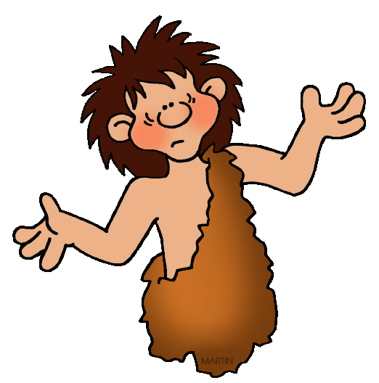
Autumn 2

English
Ug Boy – Genius of The Stone Age
Story Writing
Letter Writing
Argument
How Far Would I Go To Look Cool?
News Paper Report

Maths
Counting multiplication tables 3x 4x
Multiplication and Division
Maths Meetings
Measures, 3D Shape, Angles,
Reading Scales

Science
Rocks and Soils
Soil Investigation
Explore different types of rocks and their uses.
What are fossils?


History
The Stone Age
Examine timeline from the Stone Age to Iron Age
What can we find out about the Early Britons?
Homes

Computing
We Love Games-
Produce a game using Scratch
Use Inputs/Variables
CLC

Music Recorders

Learning notes B,A,G.
Year 3 and 4 Carol Concert

RE
Care and Concern
Bob Geldolf
Mother Teresa
Christmas

Art- Sculpture
Children to design and create clay sculptures linked to cave paintings
Use twigs, sticks etc... linked to Stone Age.

PE
Gymnastics
Floor Movements
Rolls /Jumps
Sequencing Movements
Perform/evaluate

MFL
Facts about Country
Greetings/ Name
Age
Numbers 1-11
Classroom instructions
Christmas

Christmas

