PE: Dance

Zumba!!

Literacy Word Smith
Fiction:
Maximus and the Beanstalk
Don’t read this Book

POR Poetry: poems to perform
GPS

Numeracy
- Addition & subtraction
- Measurement: money
- Multiplication & division.
- Arithmetic

Autumn 2 Year 2
Investigating Everyday Materials.
Class artist: Paul Klee
Class authors: Julia Donaldson
Class Composer: Bob Marley &
Camile Saint-Saems

PSHE

Feelings and emotions

Science: Investigating everyday materials :
- To be able to identify a range of materials and sort them according to a variety of criteria.
- To be able to identify natural an man-made materials.
- To identify that some materials can change shape by squashing, bending, stretching and twisting, and others can’t.
- To identify the suitability of metal and plastic for a variety of purposes.
- To identify different products that can be made from wood and their features and purposes.
- To identify different materials that are used for the same product.
- To identify material inventions and discoveries.

Design & Technology
Making vehicles
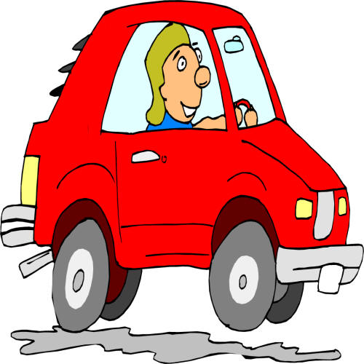
- Designing a vehicle for a purpose
- Choosing suitable materials
- Constructing
- evaluating

Art: Colour creation
- Favourite colours
- Primary colours
- Mixing colours
- Light & dark
- Kandinsky Circles

History
Remembrance
- Remembering Events
- WWI and the Armistice
- War Memorials
- Services and Silences
- Why Remember?

RE : Importance of light in religious festivals.
- Birth of Jesus - light of the world
- What is Chris tingle?
- Nativity – Festivals of light

Computing CLC
‘You’ve got mail’
- Children gain an understanding of email.
- Children learn how to send emails.
- What can I share? Importance of keeping personal information private.
- Set up and use Edmodo
- ‘let’s get posting’ children will learn how to add a profile picture/ participate in a class poll.
class ipads

