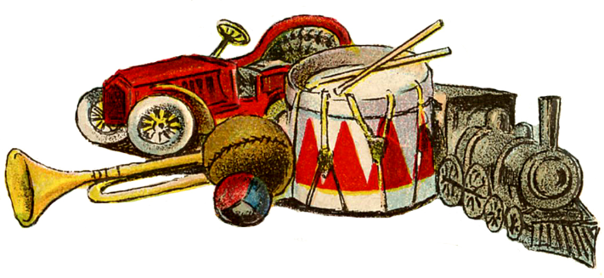

**Year 1 – Autumn 2 2018  
Topic –**

**Toys**

**Topic – Toys**

Within this topic children will learn about popular toys through the 20th and the early 21st century. Children will be thinking about their favourite toy from today before moving on to look at toys which were popular when their parents and grandparents were children.

**Science**Identifying Animals

Within our Identifying Animals topic, children will learn to identify and name some common animals, look at their understanding of carnivores, herbivores and omnivores and understand how to look after different animals.

**English  
Non-fiction – Why do elephants have big ears?**  
Children will explore the big question by reading the interactive eBook. They will learn to draw labels and write captions. By the end of the unit children will write their own report.

**Poetry – The Puffin Book of Fantastic First Poems.**

In this wide-ranging anthology, young readers are offered the opportunity to: sing, shout, whisper, chant – maybe learn by heart a range of poems.

**Computing**Pictures tell a thousand words  
Using a digital camera and iPads, children will learn how to take different shots and become more confident in capturing their own shots so that they can tell a story from their picture.

**PE**Dance

**Maths**Number: Addition and subtraction  
Geometry - Shape

**Music**

Nativity songs

**RE**Preparing for Christmas  
Why do we celebrate Christmas? How do we prepare for Christmas?

**Art & Design**

Moving Pictures  
Children will design, make and evaluate a moving picture that includes a moving mechanism.

**PE**

Children will have weekly PE lessons with UK Sports.

Children will also have a 2 week block of swimming lessons – 16th to 26th January.