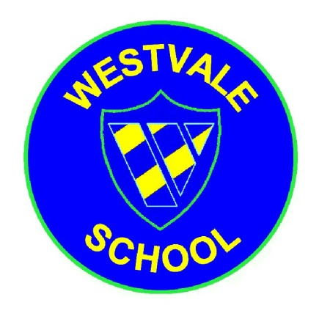
Westvale Primary School
“Striving for Excellence, Caring for All”

Headteacher: Mrs A Afflick
 Melverley Road, Kirkby, L32 0RQ
(0151) 477 8470 Fax: (0151) 477 8471
 westvale@knowsley.gov.uk  www.westvaleprimary.co.uk

‘Youth Connect 5’ course for Parents/Carers at Westvale
Youth Connect 5 is a five week course to enable parents to gain the knowledge, skills and understanding to help their children develop strong emotional wellbeing. Parents learn techniques to strengthen their child’s ability to deal with stress and adversity in life and develop skills of resilience, so that they can handle challenges and bounce back when life gets tough.
Youth Connect 5 gives you the knowledge, skills and understanding to help your children develop strong emotional wellbeing.
A ‘Youth Connect 5’ course will be starting at Westvale on Thursday mornings in September. The first session will be on Thursday 20th September, 9:15 and the course runs for 5 weeks.

Please give your name and contact details to Mrs Melvin (Learning Mentor).

Alternatively if you would like some more information about the course, or would like some more details, please contact Sharon Lee (Family Learning Team), 07825 117504.

