**Expressive Arts and Design**

Exploring using media and materials: Sings songs, makes music and dances. Safely uses a variety of tools and techniques. Experiments with colour, design and texture.

Being imaginative: Represents own thoughts, ideas and feelings through design, art, music, dance, role play and stories.

Information books, stories and poems related to topic eg ‘Elmer’, ‘Rumble in the Jungle’, ‘Little Brown Monkey’, ‘The Tiger who came to Tea’.

Paper, card, range of writing equipment.

Large 0-20 numbers for ordering. Activities for children to double, halve and share eg ‘feeding the animals’.

Jungle role play area.

Large and small construction materials – Mobilo, Duplo, Lego, Sticklebrix, wooden blocks, crates, fabrics.

Cardboard, paper, plastic for model making.

Research jungles online.

**Physical Development**

Moving and handling: Shows good control in large and small movements. Moves confidently in a range of ways, safely negotiating space. Uses tools well, including pencils for writing.

Health and self-care: Talks about ways to keep healthy and safe. Manages own basic hygiene and personal needs successfully, including dressing and going to the toilet.

Stories, poems and non-fiction books on jungle animals theme.

Writing for a purpose eg writing about events in stories we have read and writing information about animals.

Ordering numbers to 20. Counting accurately. Doubling, halving and sharing.

Re-enacting animal stories, going on safari, minibeast hunts.

Construction materials for children to make animal models.

Junk materials to make models based on own ideas.

Use of Interactive whiteboard and iPads to support Literacy, Mathematics and topic work.

**Areas of indoor / outdoor provision**

Reading areas in and outdoors

Writing areas in and outdoors

Maths in and outdoors

Role play

Construction in and outdoors

Creative - art and workshop

Technology

**Understanding The World**

People and communities: Knows about similarities and differences between themselves and others and among families, communities and traditions.

The world: Knows about similarities and differences in relation to places and living things. Talks about how environments may vary from one another eg how the area they live in is different to the jungle.

Technology: Recognises that a range of technology is used in places such as homes and schools. Selects and uses technology for particular purposes.

**Mathematics**

Numbers: Can count reliably with numbers to 20, placing them in order and saying the number that is 1 less or 1 more than a given number. Can solve problems including doubling, halving and sharing. Can count in twos, fives and tens.

Shape, Space and Measures: Uses everyday language to talk about size, weight, capacity, position, distance, time and money. Can create and describe patterns. Uses mathematical language to describe flat 2D shapes and solid 3D shapes.

**Summer 2 2018**

**Down in the Jungle**

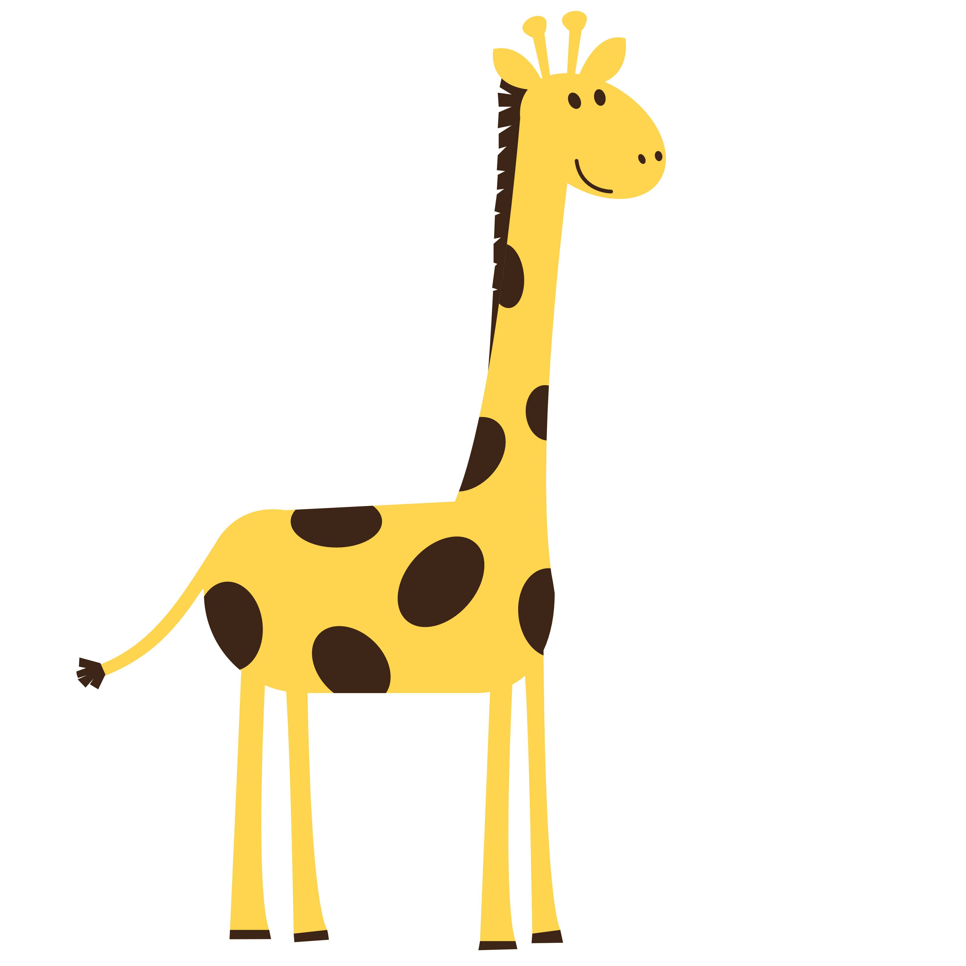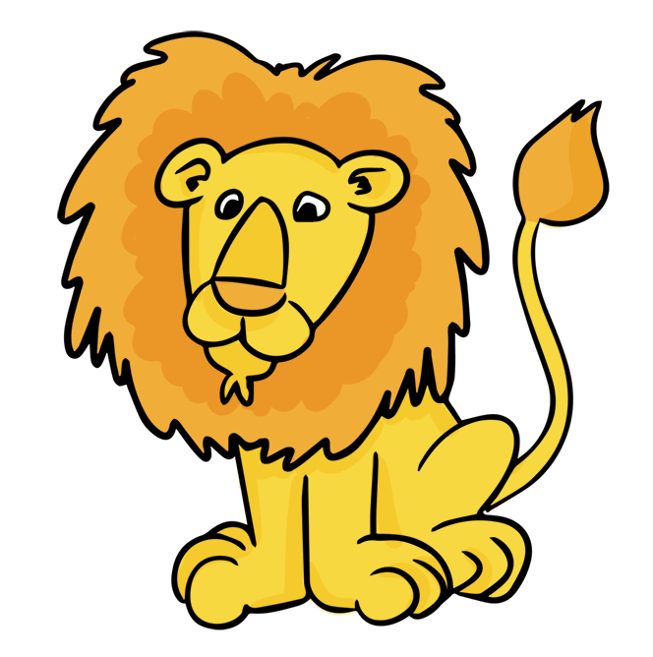 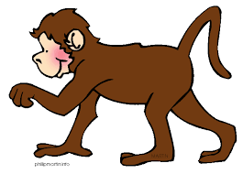 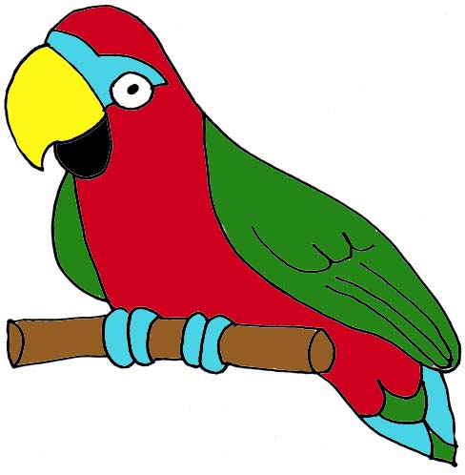 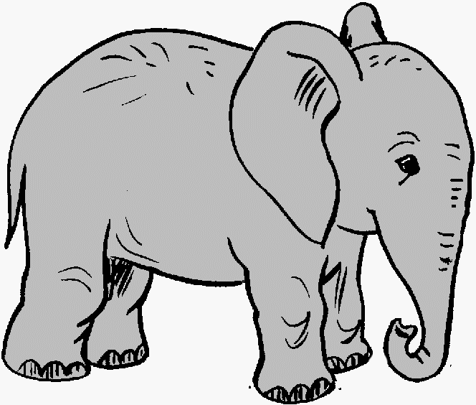

**Communication and Language/**

**Reading and writing**

**Listening and attention:** Listens to stories, anticipates key events, responds with relevant comments

**Understanding:** Answers ‘how’ and ‘why’ questions in response to experiences or stories.

**Speaking**: Can express themselves effectively, using past, present and future tenses accurately.

**Reading:** Reads and understands simple sentences. Shows understanding when talking to others about what they have read.

**Writing:** Writes simple sentences which can be read by themselves and others. Some words will be spelt correctly and others will be phonetically plausible.

**Managing Feelings and Behaviour:**

Works as part of a class, understanding and following the rules.

**Self-Confidence/Self-Awareness:**

Confident to try new activities, speak in front of others and say when they need help.

**Making Relationships:**

Plays co-operatively, taking account of others’ feelings. Forms positive relationships.

**Reception Medium Term Planning Summer 2 2018**

**Book focus for this half term – ‘Augustus and his Smile’ by Catherine Rayner.**

**Specific areas of learning – Understanding the World, Reading, Writing and Maths.**

**Areas of learning**

Reading

Writing/Physical Development

Numbers

Shape, space and Measures

Understanding The World

Expressive Arts and Design/Communication and Language

**Focused Activities**

Uses phonic skills to read words and simple sentences. Applies all sounds learnt in Jolly Phonics. Links letters to sounds, using songs and actions to support learning. Shows interest in a range of stories, poems and information books.

Writes sentences about own interests and animal topic. Holds a pencil correct and writes recognisable letters, mostly formed correctly.

Adds, subtracts and orders numbers. Can double, halve and share amounts.

Uses mathematical language to describe shapes. Creates and describes patterns.

Shows care and concern for living things and the environment eg jungle animals.

Uses themes from stories in role play, using relevant vocabulary. Initiates new combinations of movement to express feelings and ideas.

**Resource implications**

 Jolly Phonics CD and baskets containing letter sound cards, word cards using sounds taught. Non-fiction books and stories about jungle plants and animals.

Whiteboards/markers, paints, pencils/pens, paper/card.

Magnetic numbers, counting and ordering worksheets.

2D and 3D shapes. Objects for making patterns.

Information books, story books and internet information about jungles and rainforests.

Songs on jungle animal theme.