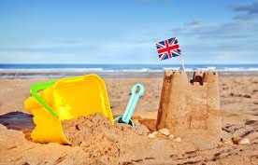B

**Art & Design**

Andy Goldsworthy

Children will look at a variety of Andy Goldsworthy work and use it as inspiration to create their own artwork.

**Maths**Number: Multiplication and Division

Number: Fractions

Measurement: Money

Measurement: Time

**PE**Games

**English  
  
Non-fiction - Top Jobs**

Children will read an interactive eBook & answer the question, ‘Which is the best job?’ They will learn how to write a job application, focusing on what they think they are good at & will plan & write their own instruction text.

**Poetry – Growing Up**

Children will explore, read, listen to & begin to write their own poems based on a range of different poets work.

**Science**

Identifying Plants

Within this unit children will learn about a variety of plants. They will learn how to identify & describe a garden plant, wild plants & a variety of trees. Children will plant their own seeds & observe them growing.

**Year 1 – Summer 2 2018  
Topic –**

**Beside the Seaside**

**Topic – Beside the Seaside**

Within this topic children will learn about the georgraphical features of the seaside, both human & physical. Children will look at a range of seaside resorts in the UK and will compare similarities and differences between seaside resorts and their locality. We will also look at the history of the seaside & how times have changed.

There will be an opportunity for parents/ carers to come into school for an afternoon workshop to create your own Punch & Judy theatre.

**PE**

Children will have weekly PE lessons with UK Sports.

Children will also have a 2 week block of swimming lessons – 16th to 26th January.