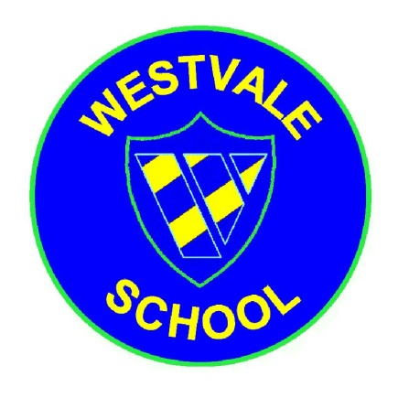
Westvale Primary School
“Striving for Excellence, Caring for All”

Headteacher: Mrs A Afflick
 Melverley Road, Kirkby, L32 0RQ
(0151) 477 8470 Fax: (0151) 477 8471
 westvale@knowsley.gov.uk  www.westvaleprimary.co.uk

Dear Parent(s)/Carer(s), 13th March 2018
It is only a couple of days now before our performance at the Echo Arena – Friday 16th March. I hope that you can come along to watch the show, the children have been practising hard, and I may be biased, but they sound fabulous!

Just a few points about the day:
- The children will be wearing a green t-shirt, so you can spot us easily on stage. I will send home the t-shirts on Thursday night so they can come into school in them on Friday. They must wear them with school trousers/skirts and sensible black shoes.
- Children should come to school at the normal start time. We will be leaving school at 10.30am by coach so we can be at the Arena by 11.30am.
- Children will be provided with a school packed lunch for their lunch time meal.
- Children will need to bring a packed lunch themselves to have for their evening meal at the Arena. Lunches should be in plastic bags that we can discard with once finished.
- The day will be spent having rehearsals. We will have some free time and
if the weather is nice enough, we will go for a walk around the Albert Dock.
- If you are coming to watch the show – it starts promptly at 7.00pm.
- After the show, we will be returning to school by coach with the children. Arrival time back at school should be approx 9.45pm.
- If you wish to take your child home yourself after the show you can inform a staff member and collect them from our school meeting point inside the entrance of the Conference Centre. Staff attending the performance are myself, Mrs Afflick (Headteacher), Mr Carson (Y4 teacher) and Mrs Geddes (1st Aider/Office).
If you have any further questions about the day, then please contact me at school.

Kind regards

Mrs J Haywood
Deputy Headteacher

