[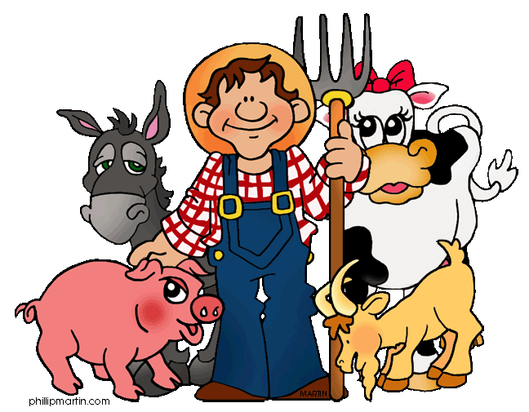](http://www.google.co.uk/url?sa=i&rct=j&q=&esrc=s&source=images&cd=&cad=rja&uact=8&ved=0ahUKEwj_lNzsvrHZAhWDvBQKHaLSAogQjRwIBw&url=http://cliparting.com/free-farm-clipart-15744/&psig=AOvVaw0c1uRXdwbdn3MzH1neWKBI&ust=1519112929968930)B

**Art & Design**

Let’s Sculpt  
  
As well as children making their own 3D homes, children will also be sculpting.

Children will be introduced to 6 sculptors and will make their own sculptures using a range of materials.

**Maths**Number: Addition and subtraction

Number: Place Value

Measurement: Length and Height

**PE**Games

**Science**

Seasonal Changes: Spring to Summer

The children will continue their investigation on the different seasons and will make comparisons between the two seasons, as well as across all four seasons. They will explore the signs of spring and summer.

**Music**

Charanga

**English  
  
Beegu by Alexis Deacon**

Children will read the fiction text Beegu. Through reading this story children will have the opportunity to create a variety of pieces of writing such as: free verse poetry, instructional writing, letter writing, play script and a Guide to Earth.

**Year 1 – Spring 2 2018  
Topic –**

**On the farm**

**RE**

Easter and Surprises

The children will learn why Easter is such an important time for Christians.

It will also explain some of the significant days of Holy Week which lead up to Easter.

**Topic – On the farm**

Within this topic children will explore the different types of farms, the features of them, how the different seasons affect life on the farm and to compare life on the farm to life in the city. Children will create posters to encourage visitors to a farm.

**PE**

Children will have weekly PE lessons with UK Sports.

Children will also have a 2 week block of swimming lessons – 16th to 26th January.