Nursery Spring 1

Super Story Tellers.

Traditional Tales.

[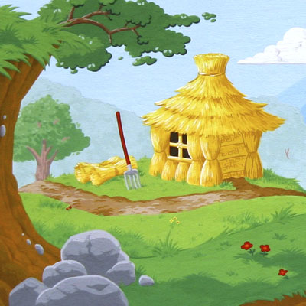](https://www.google.co.uk/url?sa=i&rct=j&q=&esrc=s&source=images&cd=&cad=rja&uact=8&ved=0ahUKEwjN78fr3JPYAhVCzxQKHePaAEYQjRwIBw&url=https://www.thinglink.com/scene/851157429763702784&psig=AOvVaw3Jb63jDStTdTrcOT-u-ODt&ust=1513692148649053)

**Physical Development.**

This half term nursery will be full of a range of activities focusing on developing our physical skills in a range of ways. We will be using the climbing equipment outdoors to use alternate feet to climb, moving freely in a wide range of ways through games and activities, learning to balance on one foot and catch a large ball safely. We will also be encouraging the children to develop their independence as much as possible by encouraging them to dress independently.

**Communication and Language.**

Children will be encouraged to use more complex sentences when communicating, use talk to connect ideas and begin to use a range of tenses.

As we focus on a range of traditional tales this half term the children will begin to develop increasing attention and recall to stories. Being able to retell a story in their own words or remember familiar phrases. We will be beginning to understand ‘how’ and ‘why’ questions as well as prepositions.

**Understanding the World.**

Nursery will be exploring technology toys. Looking at how we operate them and showing skill in making toys work by pressing parts or lifting flaps to achieve effects such as sounds, movements or images. We will be talking about significant events in our own experiences and beginning to show an interest in the lives of people who are important to us.

**Expressive Art and Design.**

Nursery will be tapping out simple repeated rhythms in phonics and exploring how sounds can be changed. We will be using a variety of construction materials to make enclosures and spaces and will be beginning to build stories around our toys.

**Personal, Social and Emotional Development.**

Throughout this half term nursery will be encouraged to enjoy the responsibility of carrying out small tasks and begin to tolerate delays when their needs are not immediately met. As the children begin to make friendships they will be encouraged to demonstrate friendly behaviours and develop good relationships through play. We will be continuing to focus on the importance of taking turns and sharing with others within our classroom.

**Literacy.**

This half term we will be becoming super story tellers and will be focusing on traditional tales such as ‘Goldielock’, ‘The Three Little Pigs’, ‘Little Red Riding Hood’ and many more. The children will be encouraged to join in with repeated refrains, anticipate key events and suggest how a story might end.

Children will continue to be encouraged to use different resources such as paints, crayons, pencils to make creative marks and give meanings to them.

**Mathematics.**

Daily maths activities will support your child to begin to use some number names and number language spontaneously. Children will begin to understand that numbers identify how many are in a set and sometimes match numerals and quantities correctly.

In shape children will be encouraged to become aware of similarities of shapes in the environment and take part in sustained construction activities. We will also be using positional language.