**Areas of learning**

Reading

Writing

Physical Development

Numbers

Shape, space and Measures

Understanding The World

Expressive Arts and Design/Communication and Language

**Areas of indoor / outdoor provision**

Reading areas in and outdoors

Writing areas in and outdoors

Maths in and outdoors

Role play in and outdoors

Construction in and outdoors

Small world

Creative - art and workshop

Interactive Whiteboard, class computer, iPads.

**Focused Activities**

Uses phonic skills to read words and simple sentences. Continue Jolly Phonics – linking letters to sounds, using songs and actions to support learning. Shows interest in a range of story and information books.

Gives meaning to marks they make as they draw, write and paint. Continues a rhyming string eg truck/duck, train/rain.

Handles objects safely and with control.

Counts objects including vehicles and matches to numbers. Forms numbers correctly. Says the number that is 1 less/1 more.

Discusses and describes shapes found on vehicles and uses them appropriately.

Knows about similarities and differences in relation to forms of transport. Shows interest in different occupations.

Uses themes from stories in role play, using relevant vocabulary.

Stories and information books related to Vehicle topic. Free book choices and Oxford Reading Tree books to share with parents/carers at home.

Writing for a purpose eg making bus tickets, making lists for journey.

Counting activities on transport theme. Shapes found on vehicles.

Props in role play area indoors, including costumes and props related to topic – uniforms and equipment related to transport occupations.

Construction materials eg building blocks and tyres for outdoor role play enabling children to recreate own experiences using transport.

Small world models and characters to support re-enactment of events from stories and development of story language.

Junk materials to make models of cars, boats etc.

Use of Smartboard to support Literacy, Mathematics and Transport topic.

Information books about vehicles and stories on theme eg ‘Duck in the Truck’, ‘The Train Ride’, ‘Terrific Trains’.

Card, range of writing equipment.

Transport themed counters. Shape and counting worksheets.

Transport related equipment supporting children’s imaginative play.

Large and small construction materials – Mobilo, Duplo, Lego, Sticklebrix, wooden blocks, crates, fabrics.

Small world garage, train track, farm, vehicles.

Cardboard, paper, plastic for model making.

Transport information online.

**Resource implications**

 Jolly Phonics CD and baskets containing letter sound cards, word cards using sounds taught. Fiction and non-fiction transport books.

Whiteboards/markers, paints, pencils/pens, paper/card.

Scissors, cutting activities.

Magnetic numbers, vehicle counters, counting worksheets.

2D and 3D shapes, construction equipment.

Information books, story books and internet information about transport.

Role play and small world models to support imaginative play and language development.

**Reception Medium Term Planning Spring 1 2018**

**Specific areas of learning** – **Reading and Understanding the World.**

**Managing Feelings and Behaviour:**

Understands that own actions affect other people, for example, tries to comfort another child when they realise they have upset them.

**Making Relationships:**

Explains own knowledge and understanding, and asks appropriate questions of others.

**Self-Confidence/Self-Awareness:**

Is confident to talk to other children when playing, and will communicate freely about own home and community.

**Spring 1 2018**

**Transport**

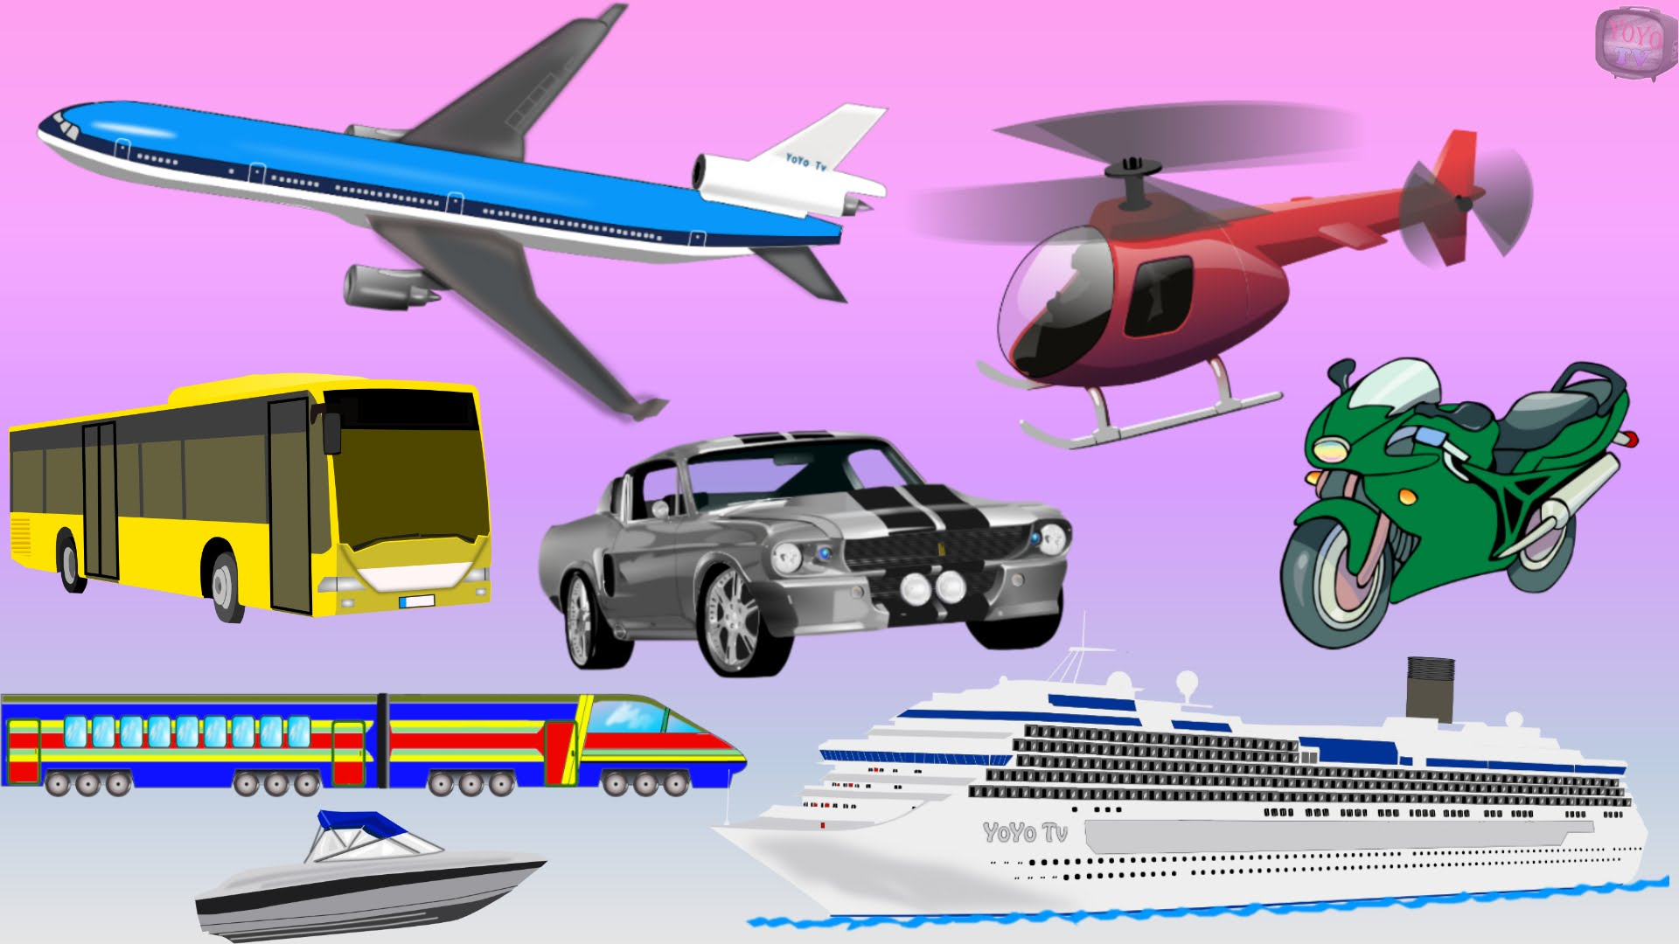

**Mathematics**

Numbers: Counts vehicles (up to 5, 10, 20) and writes corresponding number. Says the number that is 1 less or 1 more.

Shape, Space and Measures: Uses familiar objects and common shapes to create and recreate patterns and build models of vehicles. Selects a particular named shape for construction tasks eg circles for wheels on vehicles, squares for windows, rectangles for doors

**Communication and Language/**

**Reading and writing**

Listening and attention: Maintains concentration and sits quietly during appropriate activity.

Understanding: Begins to understand ‘why’ and ‘how’ questions.

Speaking: Uses talk to organise, sequence and clarify thinking, ideas, feelings and events.

Reading: Knows that information can be retrieved from books and computers. Begins to read words and simple sentences.

Writing: Gives meaning to marks they make as they draw, write and paint. Continues a rhyming string.

**Understanding The World**

People and communities: Shows interest in different occupations eg pilot, ship’s captain, astronaut.

The world: Comments and asks questions about aspects of their familiar world such as the place where they live eg discussions about transport they use.

Technology: Knows that information can be retrieved from a computer, as well as books.

**Expressive Arts and Design**

Exploring using media and materials: Manipulates materials to achieve a planned effect. Constructs with a purpose in mind, using a variety of resources.

Being imaginative: Captures experiences and responses with a range of media, such as music, dance and paint and other materials or words. Engages in imaginative role-play based on own first-hand experiences eg pretending to drive a car or be a passenger on a train.

**Physical Development**

Moving and handling: Handles tools, objects, construction and malleable materials safely and with control. Uses simple tools to effect changes to materials eg scissors to cut cardboard to make vehicles.

Health and self care: Shows understanding of how to transport and store equipment safely, eg with construction blocks in the outdoor area.