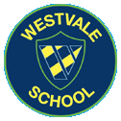
Westvale Primary School
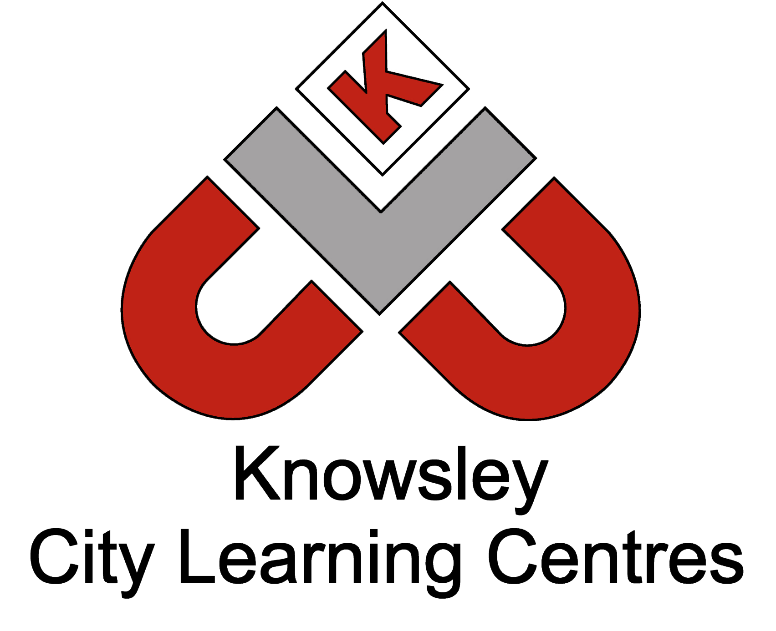

Online Safety Newsletter: Jan 2018

BBC launches ‘Own It’ website
Do you know the online safety lingo?

CEOP - Child Exploitation and Online Protection dedicated to eradicating the sexual abuse of children.

Acronyms

182: I hate you

WYCM: Will you call me
‘Own It’ is a website for 9 to 12 year olds to help them get the most out of being online. It covers everything from online privacy and avoiding malware to dealing with everyday dilemmas children face online. ‘Own It’ will work with an advisory network of partners to help ensure it covers a wide range of topics and issues affecting children online. https://www.bbc.com/ownit

#WhoIsSam – start a conversation
The National Crime Agency (NCA) have conducted an online survey which showed that while the majority of parents speak to their children regularly, over 30% had not spoken to their children about online safety in the last month. The NCA have produced a short animation narrated by a fictional character called Sam, an adult who goes online to abuse children, with the hashtag #WhoIsSam to show how offenders attempt to build relationships with young people online. https://youtu.be/AOu5BLGNG9c

Ofcom Report

Ofcom’s latest report examines children’s media use. It provides detailed evidence on media use, attitudes and understanding among children and young people. The report also includes findings relating to parents’ views about their children’s media use, and the ways that parents seek – or decide not – to monitor or limit use of different types of media. More 3-4, 5-7s and 8-11s are online than in 2016.
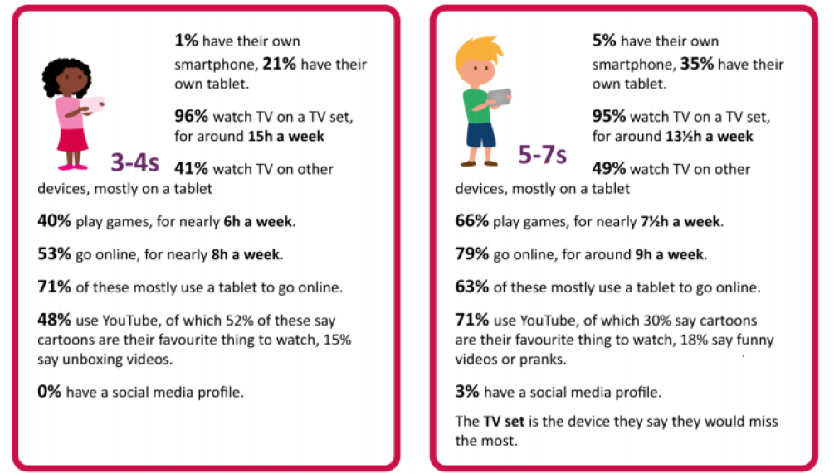
https://www.ofcom.org.uk/research-and-data/media-literacy-research/childrens/children-parents-2017

