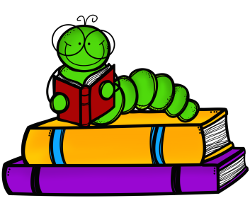 Family Literacy.
We are excited to announce the start of our fantastic free Family Literacy course on Wednesday 31st January for Nursery, Reception and Year1 children.
Are you interested in:
- Supporting your child’s literacy skills?
- Learning with other parents and making new friends?
- Opportunities to gain accreditations?
- Free literacy resources?
- Increasing your confidence in literacy?
- Opportunities to develop your own skills and continue to support your child?
- Hot drinks and refreshments?
- Spending some quality time with your child and their learning?

Family Literacy is a great opportunity to join in a fun and friendly club aimed at promoting literacy with your child.
The course runs for 10 weeks, every Wednesday afternoon 1:30 - 3:15pm and will involve exciting and educational activities for children and adults as well as hot drinks and refreshments.
This is a unique opportunity to attend a joint session with a teacher and tutor to develop yours and your child’s literacy knowledge and understanding. Practical tips, resources and activities will be shared to support your child in school and at home. As well as creating a space to make links and new friends.
If you are interested in taking part in this fantastic free course please ask your child’s teacher for a letter or speak to Miss. McCleery for more information.

