What is the Short Family Cookery Course?
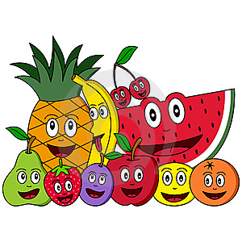
The Short Family Cookery Course is a family learning programme designed to help parents/carers focus on Healthy Eating in a fun way. Each week there is a focus on an aspect of Healthy Eating and an opportunity to make a Healthy Recipe with your child. You and your child will learn practical cooking skills and basic food hygiene.

Activities are carried out once a week. The activities will involve parents/carers and children working together.

Venue: Westvale Study Room
Date: Tuesday 20th June
Time: 2:00pm- 3:00pm parents/carers
Children join in from 3:15pm – 4:00pm (Afterschool)

Your commitment

- To attend 3 sessions
- Each session lasts for approximately 2 Hours
- To try out simple recipes with your child in the session and at home.
- To try new foods and encourage your child to try new foods.
- Talk with, and listen to your child.
- A willingness to join in and have fun!

ALL RESOURCES AND INGREDIENTS NEEDED FOR THE SESSIONS WILL BE PROVIDED FREE OF CHARGE.

Please return reply slip by Monday 19th June and a text will be sent to confirm your place Monday evening.
Many Thanks
------------------------------------------------------------------------------------------
Yes, I am able to attend the short cookery course in Westvale on Tuesday 20th June

Name: ___________________________ Phone number:____________________

Child’s Name and class:__________________________________________________

