CURRICULUM OVERVIEW YEAR 1
 | Autumn |  | Spring |  | Summer
SCIENCE | Identifying Animals  Everyday Materials |  | My Body  Seasonal Change |  | Identifying Plants  Seasonal Change
HISTORY | Guy Fawkes /Toys |  | Homes |  | Seaside
GEOGRAPHY | The Four Seasons |  | On the Farm |  | Seaside
DESIGN & TECHNOLOGY | Moving Pictures |  | Homes |  | Eat more Fruit & Veg
ART & DESIGN | Paper Art |  | Self Portraits |  | Andy Goldsworthy
COMPUTING | Walking with Dinosaurs  Pictures that tell a 1000 words |  | App Attack  Crazy Creatures |  | Young Investigators  We’re all Connected
RELIGIOUS EDUCATION | Harvest of Hands  Preparing for Christmas |  | New Beginnings  Easter Surprise |  | Our Planet
MUSIC | Charanga |  | Charanga |  | Charanga
PHYSICAL EDUCATION | Games  Gymnastics |  | Dance  Gymnastics |  | Dance  Games
ENRICHMENT/VISITS | Pantomime |  | Farm Visit |  | Seaside  Philharmonic Hall
AUTHOR  Martin Waddell & Michael Rosen  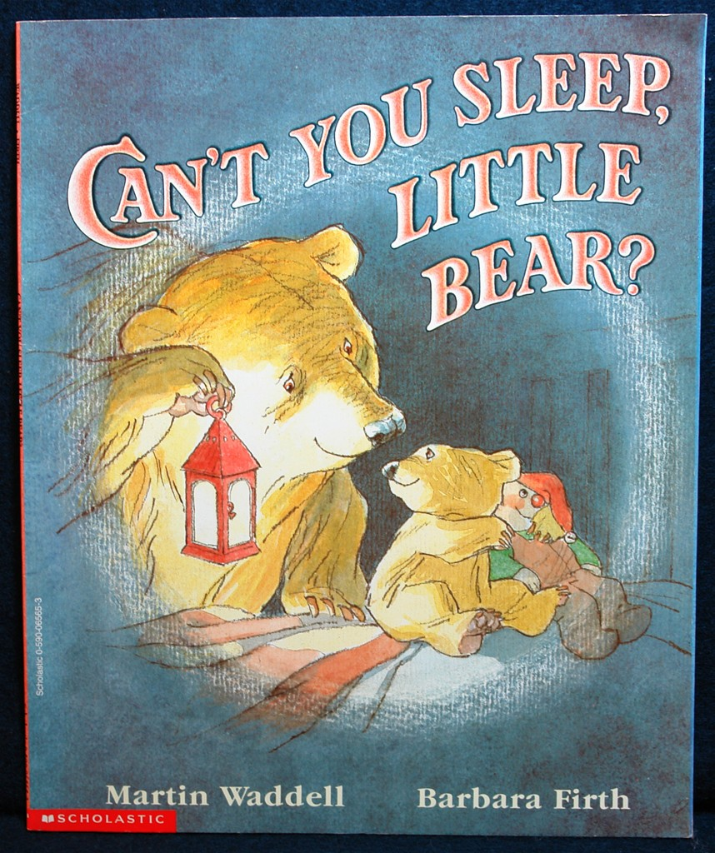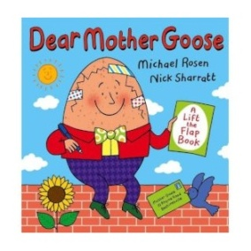 |  | ARTIST  Mondrian  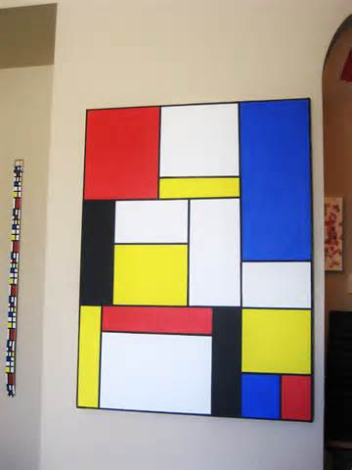 |  | COMPOSER  Vivaldi  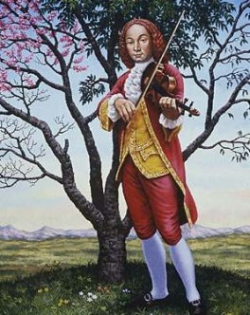

CURRICULUM OVERVIEW YEAR 2
 | Autumn |  | Spring |  | Summer
SCIENCE | Exploring Everyday Materials  Variation |  | Habitats  Growth and Survival |  | Growing Plants
HISTORY | Remembrance |  | Florence Nightingale |  | Great Fire of London
GEOGRAPHY | Where I live |  | Let’s go on Safari |  | Around the World
DESIGN & TECHNOLOGY | Perfect Pizza |  | Puppets |  | Vehicles
ART & DESIGN | Investigating materials |  | Paul Klee  Guiseppe Arcimboldo |  | Colour Creation
COMPUTING | You’ve got mail  Whatever the weather |  | Code-tastic  Super Sci-fi |  | Let’s Fix it  Young Authors
RELIGIOUS EDUCATION | Belonging  Hinduism |  | Special Places  Easter Alive |  | Me and my Family and Friends
MUSIC | Charanga |  | Charanga |  | Charanga
PHYSICAL EDUCATION | Games  Gymnastics |  | Dance  Gymnastics |  | Dance  Games
ENRICHMENT/VISITS | Pantomime |  | Zoolab |  | Safari Park
AUTHOR  Julia Donaldson & Jez Alborough  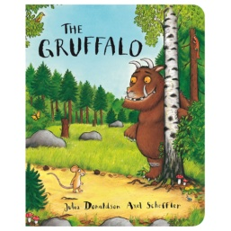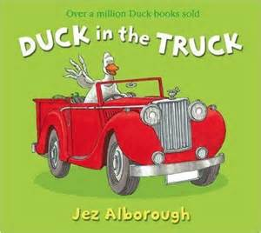 |  | ARTIST  Van Gogh  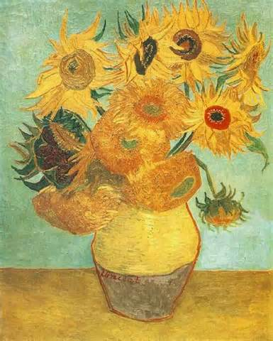 |  | COMPOSER  Bob Marley

CURRICULUM OVERVIEW YEAR 3
 |  | Autumn |  |  |  | Spring |  |  |  | Summer
SCIENCE |  | Animals including humans  Rocks |  |  |  | Forces and Magnets |  |  |  | Light  Plants
HISTORY |  | The Stone Age |  |  |  | The Wild West |  |  |  | The Romans
GEOGRAPHY |  | The Rainforest |  |  |  | Deserts |  |  |  | Countries of the World
DESIGN & TECHNOLOGY |  | Building a shelter |  |  |  | Textlies – sewing |  |  |  | Food
ART & DESIGN |  | Sculpture |  |  |  | Sketching – Mackintosh |  |  |  | Printing and Mosaics
COMPUTING |  | Get Blogging  My First Programme |  |  |  | We are publishers  Class democracy |  |  |  | We love games  Big Robots
RELIGIOUS EDUCATION |  | Rules and Responsibility  Care and concern / Christmas |  |  |  | Sikhism  Easter |  |  |  | Special places  Special people
MUSIC |  | Recorders  Performing Together |  |  |  | Recorders |  |  |  | Recorders  Mozart
PHYSICAL EDUCATION |  | Dance  Gymnastics |  |  |  | Swimming  Basketball |  |  |  | Badminton  Outdoor activities
FRENCH |  | Greetings/ numbers  Classroom instruction |  |  |  | Colours/animals/counting  Where I live / Easter |  |  |  | Months/days  Birthdays/ celebrations
ENRICHMENT/VISITS |  | CLC Visit |  |  |  | Visit a Sikh Temple |  |  |  | Chester
AUTHOR  Dick King Smith  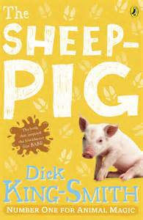 |  |  |  | ARTIST  Remy Mackintosh  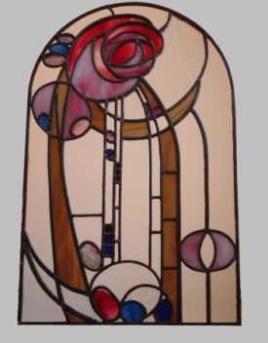 |  |  |  | COMPOSER  Mozart  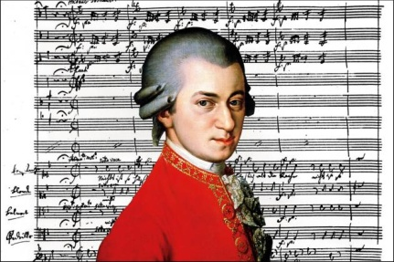
CURRICULUM OVERVIEW YEAR 4
 | Autumn |  |  |  | Spring |  |  |  | Summer
SCIENCE | Animals including humans |  |  |  | Electricity  Classifying living things |  |  |  | Sound  Solids, Liquids & Gases
HISTORY | Ancient Egypt |  |  |  | Tudors |  |  |  | Vikings
GEOGRAPHY | Place study of Egypt |  |  |  | Our European Neighbours |  |  |  | Investigating our local area
DESIGN & TECHNOLOGY | Pop Up story books |  |  |  | Tudor Houses |  |  |  | Viking boats/shields
ART & DESIGN | Sculpture – canopic jars |  |  |  | European Art |  |  |  | Liverpool Skyline
COMPUTING | Simulation  Producing wiki blogs |  |  |  | Making Movies  Making Games |  |  |  | Making reports  Trip slideshow
RELIGIOUS EDUCATION | Buddhism  Angels/Shepherds story |  |  |  | The Bible  Easter |  |  |  | Special places  Journeys
MUSIC | Keyboards  Music from different countries |  |  |  | Keyboards |  |  |  | Keyboards  Liverpool music
PHYSICAL EDUCATION | Gymnastics  Swimming |  |  |  | Dance  Hockey |  |  |  | Athletics  Striking & fielding
FRENCH | Body Parts  Animals |  |  |  | Fruit & veg / numbers  Easter |  |  |  | Classroom equipment  European countries
ENRICHMENT/VISITS | Liverpool Museum |  |  |  |  |  |  |  | Speke Hall
AUTHOR  David Walliams  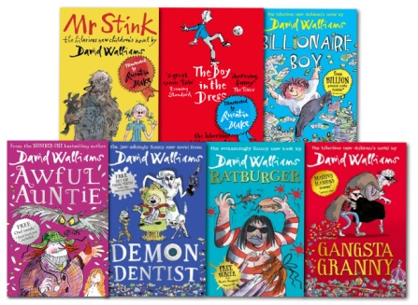 |  |  | ARTIST  Andy Warhol  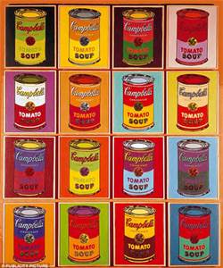 |  |  |  | COMPOSER  Freddie Mercury
CURRICULUM OVERVIEW YEAR 5
 |  | Autumn |  |  |  | Spring |  |  |  | Summer
SCIENCE |  | Forces in Action |  |  |  | Materials  Earth & Space |  |  |  | Living things & their habitats  Changes and Reproduction
HISTORY |  | Viking v Anglo Saxons |  |  |  | Ancient Greeks |  |  |  | The Shang Dynasty
GEOGRAPHY |  | Extreme Earth |  |  |  | The UK |  |  |  | North America
DESIGN & TECHNOLOGY |  | Making Bread |  |  |  | Containers – Greek Pots |  |  |  | Moving Toy
ART & DESIGN |  | Saxon jewellery  Salvador Dali |  |  |  | Still life/objects with meaning  Jackson Pollock |  |  |  | Talking textiles – tapestry of North American myth
COMPUTING |  | Making Games  News Room |  |  |  | Maths & Cryptography  Interactive Art Exhibition |  |  |  | Website designers  Let’s change the world
RELIGIOUS EDUCATION |  | Precious  Christmas in Art |  |  |  | Christians and the Bible  Easter |  |  |  | Islam  Cathedrals
MUSIC |  | Music Express  Harvest Songs |  |  |  | Music Express  Greek Music/Dance |  |  |  | Music Express
PHYSICAL EDUCATION |  | Gymnastics / Team Games  Dance |  |  |  | Basketball/  Tennis |  |  |  | Athletics / Swimming  Rounders
FRENCH |  | Greetings & conversation  Body parts / feelings |  |  |  | Places around school  Clothing |  |  |  | Weather
ENRICHMENT/VISITS |  | Harvest |  |  |  | Museum |  |  |  | Cathedral Visit
AUTHOR  Roald Dahl  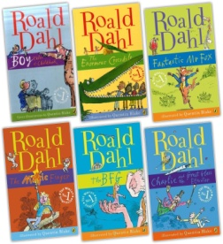 |  |  |  | ARTIST  Salvador Dali  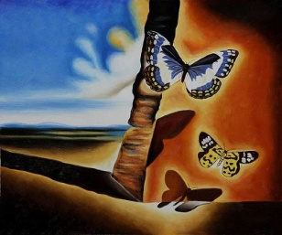 |  |  |  | COMPOSER  Andrew Lloyd Webber
CURRICULUM OVERVIEW YEAR 6
 |  | Autumn |  |  |  | Spring |  |  |  | Summer
SCIENCE |  | Evolution & Inheritance  Living things - classification |  |  |  | Light – how we see things  Electricity – changing circuits |  |  |  | Heart – circulatory system
HISTORY |  | The Aztec Empire |  |  |  | Tudor Exploration |  |  |  | Britain at War
GEOGRAPHY |  | South America |  |  |  | Mountains & Rivers
DESIGN & TECHNOLOGY |  | South American Food |  |  |  | Slippers |  |  |  | Shelters
ART & DESIGN |  | Aztec Art |  |  |  | Japanese Landscapes |  |  |  | River paintings, collage
COMPUTING |  | Let’s learn a language  Heroes and Villains |  |  |  | Appy Times  Stocks and Shares |  |  |  | Appy Times 2  Young Authors
RELIGIOUS EDUCATION |  | Christian Faith in Action  Promises and Prophecy |  |  |  | Choices  Easter in Art |  |  |  | Judaism
MUSIC |  | Exploring Rounds  Exploring Sound Sources |  |  |  | Exploring lyrics and melody  Exploring rhythm and pulse |  |  |  | Performing together  Musical processes
PHYSICAL EDUCATION |  | Invasion Games  Gymnastics |  |  |  | Swimming / Short Tennis  Dance |  |  |  | Athletics/Rounders
Spanish |  | Greetings/numbers/colours  Classroom vocab/Christmas |  |  |  | Animals  Homes/families |  |  |  | Our body/clothes  Weather/months/seasons
ENRICHMENT/VISITS |  | Cadbury World |  |  |  |  |  |  |  | Eden Camp
AUTHOR  Michael Morpurgo  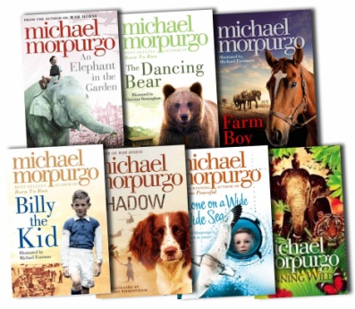 |  |  |  | ARTIST  Gaudi  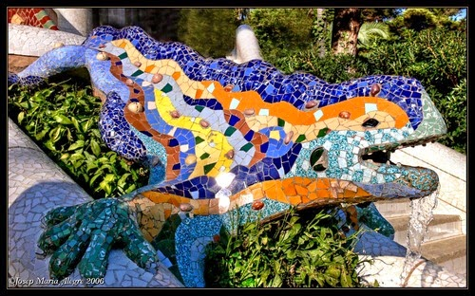 |  |  |  | COMPOSER  Gary Barlow

