CURRICULUM OVERVIEW YEAR 4
 | Autumn |  | Spring |  | Summer
SCIENCE | Animals including humans |  | Electricity  Classifying living things |  | Sound  Solids, Liquids & Gases
HISTORY | Ancient Egypt |  | Tudors |  | Vikings
GEOGRAPHY | Place study of Egypt |  | Our European Neighbours |  | Investigating our local area
DESIGN & TECHNOLOGY | Pop Up story books |  | Tudor Houses |  | Viking boats/shields
ART & DESIGN | Sculpture – canopic jars |  | European Art |  | Liverpool Skyline
COMPUTING | Simulation  Producing wiki blogs |  | Making Movies  Making Games |  | Making reports  Trip slideshow
RELIGIOUS EDUCATION | Buddhism  Angels/Shepherds story |  | The Bible  Easter |  | Special places  Journeys
MUSIC | Keyboards  Music from different countries |  | Keyboards |  | Keyboards  Liverpool music
PHYSICAL EDUCATION | Gymnastics  Swimming |  | Dance  Hockey |  | Athletics  Striking & fielding
SPANISH | Body Parts  Animals |  | Fruit & veg / numbers  Easter |  | Classroom equipment  European countries
ENRICHMENT/VISITS | Liverpool Museum |  |  |  | Speke Hall
AUTHOR  David Walliams  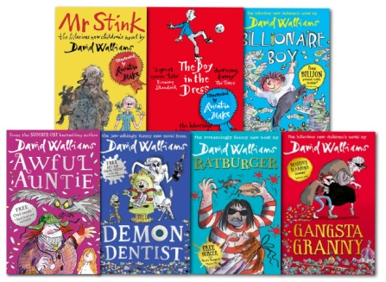 |  | ARTIST  Andy Warhol  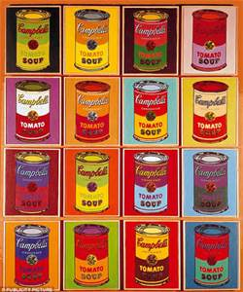 |  | COMPOSER  Freddie Mercury  