CURRICULUM OVERVIEW YEAR 1
 | Autumn |  | Spring |  | Summer
SCIENCE | Identifying Animals  Everyday Materials |  | My Body  Seasonal Change |  | Identifying Plants  Seasonal Change
HISTORY | Guy Fawkes /Toys |  | Homes |  | Seaside
GEOGRAPHY | My world and me |  | On the Farm |  | Seaside
DESIGN & TECHNOLOGY | Moving Pictures |  | Homes |  | Eat more Fruit & Veg
ART & DESIGN | Paper Art |  | Self Portraits |  | Andy Goldsworthy
COMPUTING | Walking with Dinosaurs  Pictures that tell a 1000 words |  | App Attack  Crazy Creatures |  | Young Investigators  We’re all Connected
RELIGIOUS EDUCATION | Harvest of Hands  Preparing for Christmas |  | New Beginnings  Easter Surprise |  | Our Planet
MUSIC | Charanga |  | Charanga |  | Charanga
PHYSICAL EDUCATION | Games  Gymnastics |  | Dance  Gymnastics |  | Dance  Games
ENRICHMENT/VISITS | Pantomime |  | Farm Visit |  | Seaside  Philharmonic Hall
AUTHOR  Martin Waddell & Michael Rosen  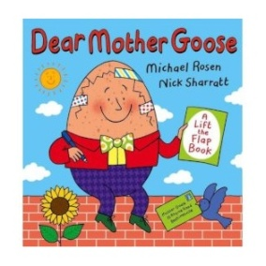 |  | ARTIST  Mondrian  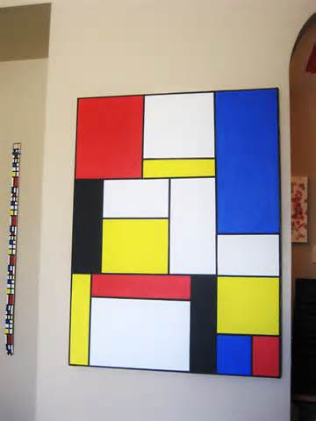 |  | COMPOSER  Vivaldi

